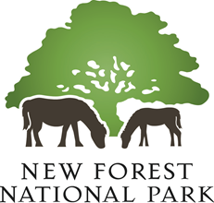

New Forest National Park Habitat Mitigation Scheme
Mitigating recreational impacts on New Forest designated sites

Annual Report on Scheme Implementation
(1 April 2024 – 31 March 2025)

1. Introduction

  - This is the annual report on the implementation of the New Forest National Park Authority’s Habitat Mitigation Scheme. It describes the progress made implementing mitigation measures from 1 April 2024 to 31 March 2025 and is published at the end of the 2025 calendar year. Contributions to the Scheme were received from net new dwellings and other forms of overnight accommodation during this period.

Implementation of Mitigation Measures

2.1 The key mitigation measures in the NPA’s Habitat Mitigation Scheme that were implemented during this year included:

- Provision of ranger resources (£42,000 of contributions used in 2024/25)
- Delivering messaging across a range of communications channels (£8,000 of contributions used in 2023/24)

2.2 The profile of development contributing to the Authority’s adopted Habitat Mitigation Scheme in 2024 – 25 was markedly different to previous years. Financial contributions from the planning permissions at the New Forest National Park Local Plan (2019) housing site allocations at the site of the former Lyndhurst Park Hotel (79 dwellings) and land at Whartons Lane, Ashurst (62 dwellings) were both received in the 2024 – 25 financial year. Between them these developments contributed over £530,000 towards the delivery of mitigation measures to address recreational impacts for the 141 net new dwellings delivered on the sites.

2.3 In addition to these larger developments, financial contributions were received from temporary ‘pop up’ campsites that typically benefit from national permitted development rights. But are still legally required to address their recreational impacts on the New Forest’s internationally designated sites.

2.4 During the 2024 – 25 reporting period, the National Park Authority received £610,713 in developer contributions towards the adopted Habitat Mitigation Scheme; and £59,875 was spent on the delivery of mitigation measures.

3. Ranger activities

3.1 One full time mitigation ranger was employed during the 2024-5 financial year. This appointment reflected advice from Natural England that impacts from development required addressing all year round; and that the employment of a full time resource was preferable to two seasonal rangers for example.

3.2 The ranger engaged with people during the season through ground nesting bird patrols, community engagement sessions, campsite monitoring and local public events. The ranger worked closely with Forestry England and other partner ranger teams as well as the wider National Park Authority ranger team to ensure consistency of messaging.

3.3 The NPA ranger team held 50 dedicated ground nesting bird focussed sessions, 22 delivered by the NPA Assistant Ranger where she engaged with 746 members of the public. She ran an additional 34 sessions focussed upon New Forest code messaging and engaged directly with 1,048 people. There was engagement with a further 2,021 members of the public through the Assistant Rangers attendance at community events, including Ringwood Eco Fair, Beaulieu Conservation Day and Dogstival.

3.4 From data collected by the Assistant Ranger this season, the most popular reason for visits to the New Forest was dog walking, which reflects the composition of visitors to the New Forest shown in the 2019 Footprint Ecology research reports.

- 46% of ranger engagements were with dog walkers, followed by 33% being walkers and photographers.

- 61% of those engaged were aware of ground nesting birds which is a positive and indicates the success of persistent annual messaging by New Forest ranger teams and Comms teams. Of the dog walkers spoken to, only 33% were aware of the potential damaging environmental issues to the SAC/SPA caused by dog faeces in the New Forest, it was encouraging that of those, 70% reported having been made aware of the issue previously by an NPA ranger.

3.5 The monitoring used this year will be reviewed and developed for 2025/26, allowing trends in data to be compared.

4. Communications

4.1 A significant element of the Mitigation Scheme is dedicated to delivering consistent key messages about the protected SPA and SAC birds, habitats and species and how recreational users can avoid impacting these.

4.2 These key messages were again included in a range of NPA publications, social media channels and website, as well as through the media and partners’ channels. NPA publications are distributed to local attractions, information points, community outlets and accommodation sites, and distributed by NPA and Forestry England rangers at public events, fairs, shows, campsites and car parks.

4.3 All these media channels allow messages to be delivered to a very large audience, and even if only a very small proportion of these lead to responsible behaviour in the protected sites, then these measures are expected to be effective. The reach of key mitigation messages included the use of:
- NPA Publications, including Essential Guide, Park Life, Pocket Guides etc – almost 400,000 copies printed.
- Social media Facebook / X (Twitter) / Instagram / LinkedIn, YouTube - impressions: 1.09 million (up 19%); engagements 37,500;
- E-Newsletter – 26,800 recipients
- Press releases, for example:
- Ground nesting bird survey finds record number in New Forest
- Consultation on proposals to extend Public Spaces Protection Orders - New Forest National Park Authority
- NPA website = 14,500 views
[NF Code page (www.newforestnpa.gov.uk/visiting/help-care-for-the-forest/new-forest-code) = 14,000.
Ground nesting birds page (Ground nesting birds - New Forest National Park Authority = 553]

  - The New Forest code and the two associated Public Spaces Protection Orders (PSPOs) are an important medium for distributing key mitigation messages. The code was included in the Pocket Guide and Park Life publications; featured in Hampshire Life magazines; signs of different sizes, posters and fliers were printed and distributed among communities and businesses. A reprint had to be ordered as supplies had run out.
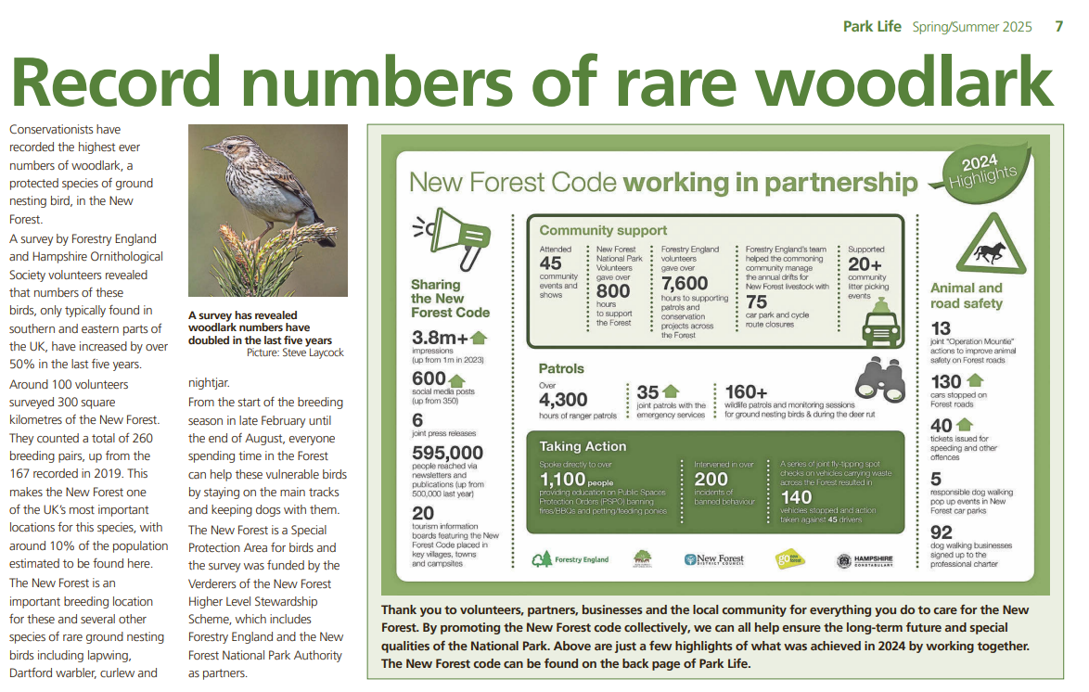
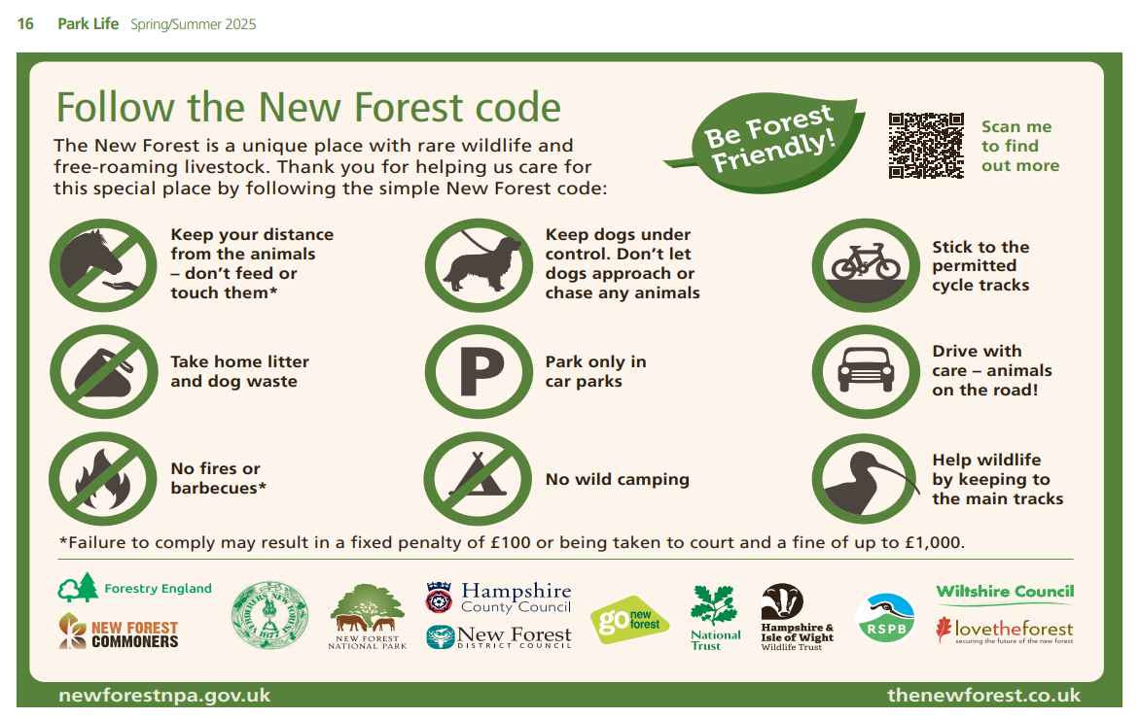

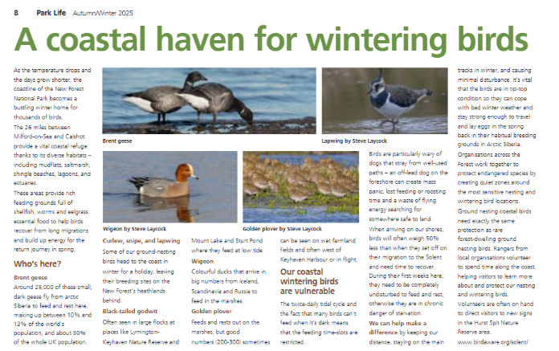

  - Results of the joint 2024 campaign were promoted in an infographic, as set out on the following page.
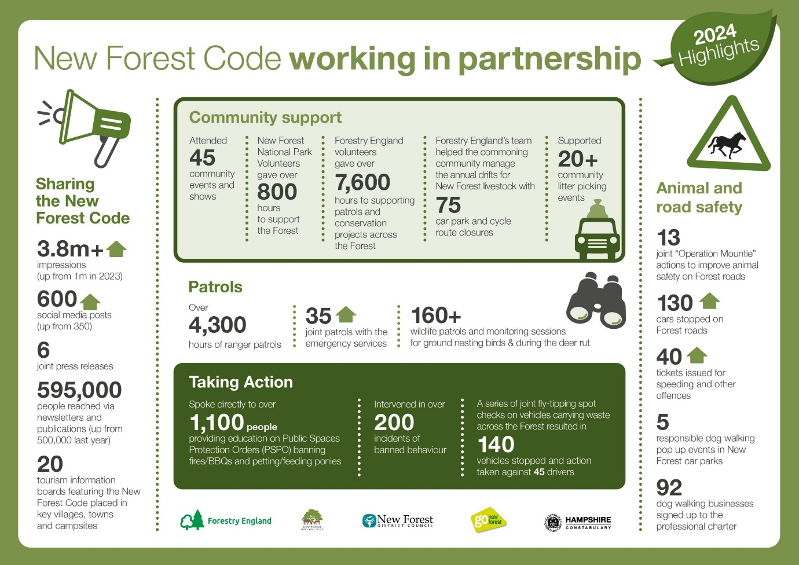

  - Enjoying the Forest survey – the 2025 survey conducted in partnership with Go New Forest and Forestry England showed that of 296 respondents, 90% were aware of the New Forest Code.

More details as follows:
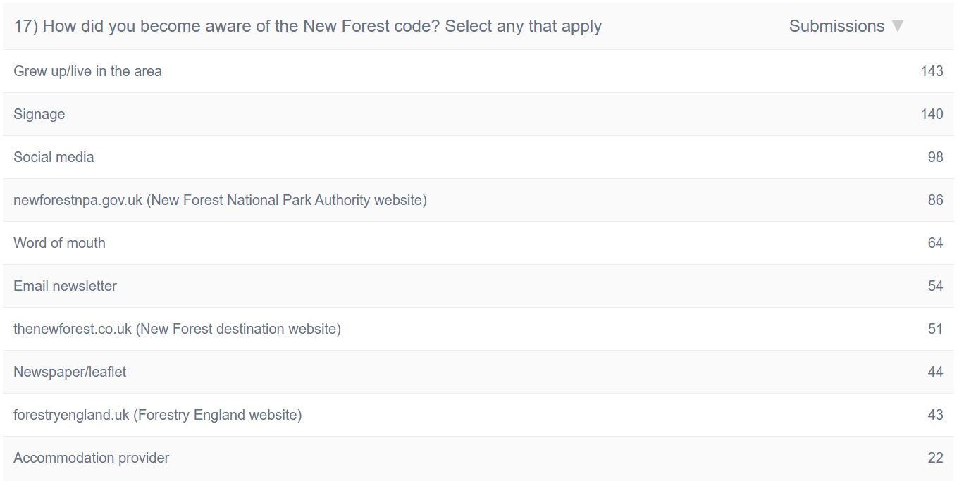
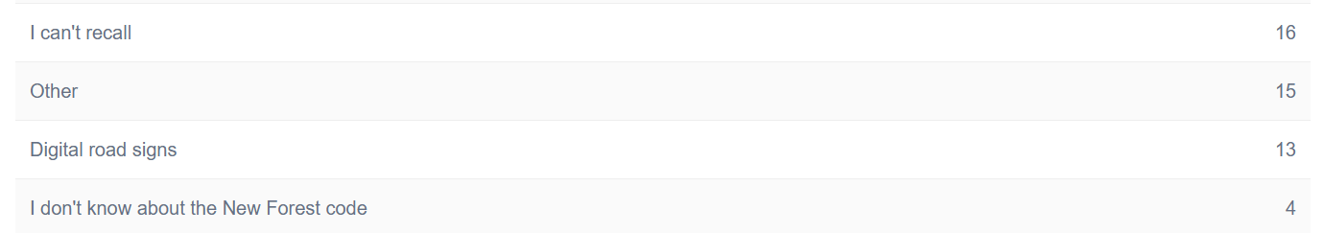

  - We launched a WhatsApp community channel which now has over 750 subscribers:
New Forest National Park Authority Launches Official WhatsApp Channel - New Forest National Park Authority.
This allows us to send out emergency and seasonal messages direct to people’s phones.

  - A new NPA website is being developed and will be going live at the end of March and we are reviewing pages and ensuring messages are clearer.

  - Working with Go New Forest and partners to take out senior hospitality managers into the Forest to press home the New Forest code and challenges in the hope they inform their guests before they arrive and while they are staying here.

  - This year’s extent and reach of delivering key mitigation messages continues to demonstrate the huge advantage of regularly using communications channels to deliver the scheme’s key messages.

  - While the Habitat Mitigation Scheme contribution is welcome, it provides a small amount of the recreation management campaign budget, with the rest being found by partners. Eg. Pocket Guide £19k; Park Life £8k.

5. Monitoring

5.1 We are constantly developing and improving our Walking App, adding more routes, more information points and better accessibility functions. From the App we gather information about the use and popularity of each of our promoted routes. We continue to monitor the number of downloads and have upgraded the app software to estimate the number of people using each route. This data will be helpful in determining whether interventions to promote certain routes away from the most sensitive designated sites will prove to be effective and to monitor the success of signage and route promotion. The app has yearly costs in addition to one-off payments for feature improvements.

6. Financial Position

Balance of funds available for mitigation measures at 31 March 2024

6.1 Funds held by the New Forest National Park Authority at 31 March 2024 were £114,218 for current plan period spending; and £175,443 in the in-perpetuity fund – giving a total of £289,661

Contributions received during the 2024/25 financial year

6.2 During 2024 – 2025, habitat mitigation contributions towards the New Forest designated sites were received from several larger developments on sites allocated in the New Forest National Park Local Plan (2019). a number of other forms of overnight accommodation and from seasonal campsites. The net total received in developer contributions available for current mitigation measures during the period was £230,930, with a further £379,782 received for the In-Perpetuity reserve for long-term mitigation measures) giving a total received income of £610,713.

Expenditure on mitigation measures during 2024/25

6.3 During the 2024 – 2025 reporting year a total of £59,875 was spent on mitigation measures, details of which are outlined in Section 2 above. Expenditure on mitigation measures comprised:

- Seasonal Rangers: Habitat mitigation contributions funded the ranger resource working in and around the New Forest SAC and SPA - £42,000

- Communications: The cost of interpretation information, publications, website and social media development - £8,000

- Promotion of alternative rights of way: This has include the enhancement of walking routes away from the designated sites – circa £6,000

Balance remaining for current mitigation measures at 31 March 2025

6.4 Following the funds received and expenditure during the year, the funds remaining and available for mitigation measures in 2025/26 are £285,272.

Starting balance: £114,218
Contributions received: £230,930
minus expenditure: £59.875

Funds available for 2024/25 £285,273

Balance of the In-Perpetuity Reserve at 31 March 2025

6.5 As at the end of March 2024 there was £175,443 in the In-Perpetuity fund. £379,782 was received in contributions during 2024/25. This means that there was a total of £555,225 in the In-Perpetuity reserve at the end of March 2025.

7. Development of a strategic habitat mitigation approach for the New Forest

7.1 The National Park Authority’s Habitat Mitigation Scheme does not address the significant scale of residential development planned in areas outside the National Park boundary and its potential impacts on the New Forest’s designated sites. This is the responsibility of neighbouring planning authorities, who are the ‘competent authorities’ under the Habitats Regulations. It is recognised by planning authorities and key partners (including Natural England) that there are significant benefits and economies of scale to be gained from working across administrative boundary to address in-combination recreational impacts from planned new development. The National Park Authority is working with Natural England and other neighbouring local authorities to develop a longer-term strategic approach to prevent adverse effects on the internationally designated nature conservation sites in the New Forest.

7.2 A significant body of research has been undertaken on the recreational use of the New Forest’s designated sites, including the main activities undertaken and where people are visiting from. All of the available evidence has been published on the National Park Authority’s website at: Research into recreational use of the New Forest’s protected habitats - New Forest National Park Authority

7.3 The research undertaken identifies a ‘zone of influence’ from the New Forest’s internationally designated sites within which the majority of recreational visits originate from. This defined 13.8km catchment or ‘zone of influence’ provides the basis for the relevant planning authorities to seek mitigation for the recreational impacts arising from new development on the protected sites of the New Forest. Natural England has endorsed the conclusions of this work and the earlier research reports and supports their use as the best available information for the purposes of undertaken Habitats Regulations Assessments (HRAs) and appropriate assessments.

7.4 Surrounding local planning authorities, together with the New Forest National Park Authority, Natural England and Forestry England, are working on a set of Strategic Access Management & Monitoring measures designed to mitigate the increased levels of visitors (from new housing in the zone of influence) once they arrive in the New Forest to enjoy their recreational trips. The attention is that the agreed Strategic Access Management and Monitoring (SAMM) measures will sit alongside the additional greenspace provision within the boundaries of each of the local planning authorities. The intention is to publish a New Forest Strategic Access Management & Monitoring Strategy in 2026 that will enable the pooling of developer contributions from across the zone of influence to fund a strategic package of mitigation measures and a robust monitoring framework.

Details of how development can impact the designated sites in the New Forest and the need for mitigation is outlined on the website at: www.newforestnpa.gov.uk/planning/development-impacts-on-protected-areas/
The In-Perpetuity reserve has been set up as part of the Revised Habitat Mitigation Scheme SPD and details can be seen at https://www.newforestnpa.gov.uk/planning/development-impacts-on-protected-areas/

