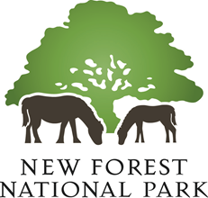

New Forest National Park Habitat Mitigation Scheme
Mitigating recreational impacts on New Forest designated sites

Annual Report on Scheme Implementation
(1 April 2023 – 31 March 2024)

1. Introduction

  - This is the annual report on the implementation of the New Forest National Park Authority’s Habitat Mitigation Scheme. It describes the progress made implementing mitigation measures from 1 April 2023 to 31 March 2024. Contributions to the Scheme were received from net new dwellings and other forms of overnight accommodation during this period.

Implementation of Mitigation Measures

2.1 The key mitigation measures in the NPA’s Habitat Mitigation Scheme that were implemented during this year included:

- Provision of ranger resources (£54,000 of contributions used in 2023/24)
- Delivering messaging across a range of communications channels (£7,500 of contributions used in 2023/24)
- Access improvements to attract recreational visit away from designated sites (£4,600 of contributions used in 2023/24)

2.2 The profile of development contributing to the Authority’s adopted Habitat Mitigation Scheme in 2023 – 24 was typically smaller-scale development. The planning applications for the New Forest National Park Local Plan (2019) housing site allocations at the site of the former Lyndhurst Park Hotel (79 dwellings); land at Whartons Lane, Ashurst (62 dwellings); and land at Church Lane, Sway (46 dwellings) have now all received detailed planning permission and development has commenced. However, the trigger for the payment of habitat mitigation contributions at these sites was not reached in the 2023 – 24 reporting year and so they do not feature within this report.

2.3 The developments contributing to the Authority’s Habitat Mitigation Scheme in 2023 – 24 included net new visitor accommodation at the Sett in Brockenhurst (application reference 21/00876) and the redevelopment of the Squirrels also in Brockenhurst (application 20/00271). The redevelopment of the former Redmayne Engineering site in Brockenhurst for 9 new dwellings contributed £32,949 towards the mitigation scheme. In addition, temporary campsite uses within the New Forest National Park are also required to address their in-combination recreation impacts on the New Forest’s designated sites and the National Park Authority seek proportionate contributions towards the adopted Mitigation Scheme from these temporary campsites.

2.4 During the 2023 – 24 reporting period, the National Park Authority received £66,854 in developer contributions towards the adopted Habitat Mitigation Scheme; and £69,870 was spent on the deliver of mitigation measures.

3. Ranger activities

3.1 Two seasonal rangers were employed during the spring/summer 2023. Dawn Smith was recruited as a full time Assistant Ranger in late June 2023, rejoining the organisation from Forestry England, having previously worked at the NPA as the NFDC mitigation funded People and Wildlife Ranger for 6 years.

3.2 The rangers engaged with people during the season through ground nesting bird patrols, engagement sessions, campsite activities, public events, and local wild play days. The mitigation ranger team worked closely with Forestry England Keepers to identify, prioritise and target the areas of work for mitigating the impacts on ground nesting birds and to ensure that the information shared with the public was current.

3.3 The rangers held 44 dedicated ground nesting bird focussed sessions, engaging with 1,104 members of the public during the season between March and August. An additional 9 sessions focussed upon New Forest code messaging and engaged directly with 156 people and there was engagement with a further 1,632 members of the public through our attendance at community events, including a Furzey Gardens Bio-blitz, New Forest Reptile Centre and Open Farm Sunday at Bisterne Farm.

3.4 During the school summer holidays, seasonal rangers engaged with just under 1,000 visitors through a successful programme of 30 New Forest Code themed events held on New Forest camp sites (additional funding received from Camping New Forest).

3.5 During this period, the Authority benefitted from the returning experience and knowledge of Dawn in relation to engaging with the public in regard to managing dogs on countryside sites. Presentations were delivered at the NFDOG and Verderers Seminar for Dog Related Businesses and at the NF Dog Owners Group AGM. The ‘impacts of dogs on protected landscapes’ mitigation work developed in the New Forest, was described as exemplary and workshops were delivered at neighbouring mitigation scheme meetings including Thames Basin Heaths, Dorset Urban Heaths Partnership and Ashdown Forest.

4. Communications

4.1 An important element of the Mitigation Scheme is dedicated to delivering consistent key messages about the protected SPA and SAC birds, habitats and species and how recreational users can avoid impacting these.

4.2 These key messages were again included in a range of National Park Authority publications, social media channels and website, as well as through the media and partners’ channels. Publications are distributed to local attractions, information points, community outlets and accommodation sites, and distributed by National Park Authority and Forestry England rangers at public events, fairs, shows, campsites and car parks.

4.3 All these media channels allow messages to be delivered to a very large audience, and even if only a very small proportion of these lead to responsible behaviour in the protected sites, then these measures are expected to be effective.

4.4 The reach of key mitigation messages included the use of:
- NPA Publications, including Essential Guide, Park Life, Pocket Guides etc – almost 400,000 copies printed.
- Social media Facebook / X (Twitter) / Instagram / LinkedIn, YouTube - impressions: 1.15 million; engagements 67,000;
- E-Newsletter – 26,500 recipients
- NPA website = 15,600 views
[NF Code page (www.newforestnpa.gov.uk/visiting/help-care-for-the-forest/new-forest-code) = 14,700.
Ground nesting birds page (Ground nesting birds - New Forest National Park Authority = 900]

  - The New Forest code is an important medium for distributing key mitigation messages, and two Public Spaces Protection Orders (PSPOs) were introduced in July 2023 with messaging on feeding/petting commoners livestock and the ban on fires/BBQs. The code was included in the Pocket Guide and Park Life publications; featured in Hampshire Life magazines; signs of different sizes, posters and fliers were printed and distributed among communities and businesses. A reprint had to be ordered as supplies had run out.

  - The code was translated into the 10 most common languages spoken in the region: Arabic, Simplified Chinese, Gujarati, Hindi, Pashto, Polish, Punjabi, Romanian, Ukrainian and Urdu, thanks to a relationship with a local translation company which completed the work at a nominal fee of £500. These were made available to download and print on the NPA website at the end of this page: New Forest code - New Forest National Park Authority.

  - Results of the 2023 campaign were promoted in an infographic:

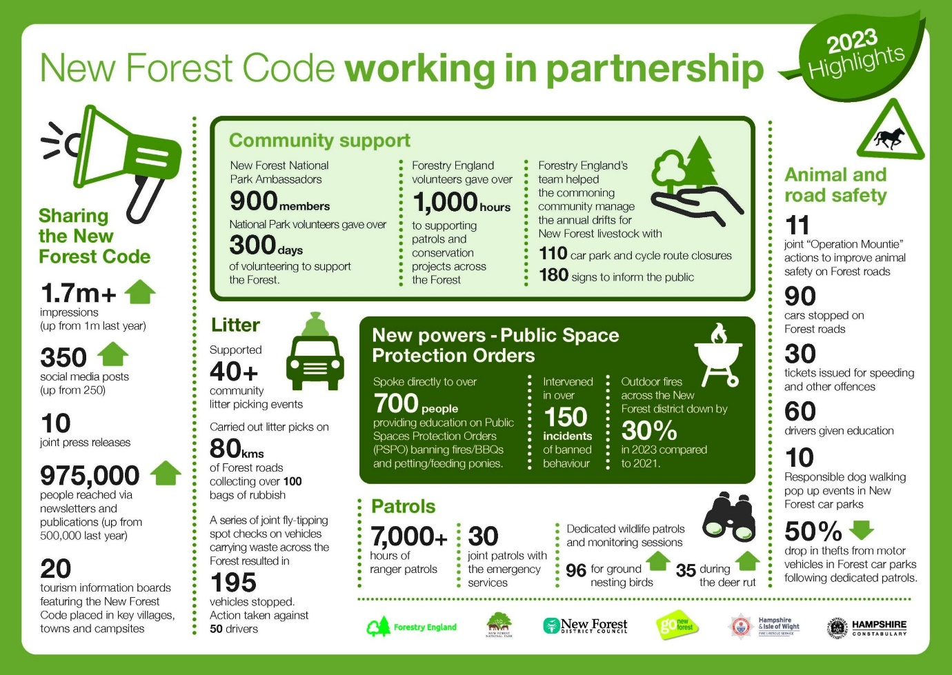

  - Welcome film – with tourism body Go New Forest and Forestry England we produced a film: Welcome to the New Forest. On YouTube this has received 91,700 views so far and has also been promoted by Go New Forest.

  - Enjoying the Forest survey – the 2023 survey conducted in partnership with Go New Forest and Forestry England showed that of 786 respondents, 86% were aware of the New Forest Code. More details as follows:

How much of the New Forest Code do you know? | Responses | Percentage
There is a New Forest Code to follow to help look after the Forest | 674 | 86%
Drive with care - animals on the road! | 757 | 96%
Take home litter and dog waste | 746 | 95%
Park only in car parks | 709 | 90%
Keep your distance from the animals don’t feed or touch them | 747 | 95%
No wild camping | 685 | 87%
Keep dogs under control. Don’t let dogs approach or chase any animals | 716 | 91%
No fires or BBQs | 723 | 92%
Stick to the permitted cycle tracks | 597 | 76%
Help wildlife by keeping to the main tracks | 632 | 80%

  - Overall, the number of people accessing and receiving messages across the various National Park Authority communication channels greatly increased again this year.

  - This year’s extent and reach of delivering key mitigation messages continues to demonstrate the huge advantage of regularly using communications channels to deliver the scheme’s key messages.

  - While the Habitat Mitigation Scheme contribution is welcome, it provides a tiny amount of the recreation management campaign budget, with the rest being found by partners and it is unlikely we are able to continue at this level. For example, Forestry England is reviewing whether it can continue with the Essential Guide. Stocks of Pocket Guides ran out in October and it is unlikely supplies will be available again until February.

5.0 Improvements to alternative recreational routes

5.1 This project involves improvements to signage on selected rights of way outside the internationally designated areas that would provide an alternative location for recreation. During the 2023 – 24 reporting year developer contributions were released to support improved waymarkers and the Franchises Wood walk. The alternative walking routes are promoted on the National Park Authority’s website at: https://www.newforestnpa.gov.uk/things-to-do/walking/new-forest-walks/

6. Monitoring

6.1 We are constantly developing and improving our Walking App, adding more routes, more information points and better accessibility functions. From the App we gather information about the use and popularity of each of our promoted routes. We continue to monitor the number of downloads and have upgraded the app software to estimate the number of people using each route. This data will be helpful in determining whether interventions to promote certain routes away from the most sensitive designated sites will prove to be effective and to monitor the success of signage and route promotion. The app has yearly costs in addition to one-off payments for feature improvements.

7. Financial Position

Balance of funds available for mitigation measures at 31 March 2023

7.1 Funds held by the New Forest National Park Authority at 31 March 2023 were £117,233.70 for current plan period spending; and £140,167.07 in the in-perpetuity fund – giving a total of £257,400.77

Contributions received during 2022/23

7.2 During 2023 – 2024, habitat mitigation contributions towards the New Forest designated sites were received from small-scale residential schemes, a number of other forms of overnight accommodation and from seasonal campsites. The net total received in developer contributions available for current mitigation measures during the period was £66,854.63 (with a further £35,275.81 received for the In-Perpetuity reserve for long-term mitigation measures) giving a total received income of £102,130.44.

Expenditure on mitigation measures during 2023/24

7.3 During the 2023 – 2024 reporting year a total of £69,870 was spent on mitigation measures, details of which are outlined in Section 2 above. Expenditure on mitigation measures comprised:

- Seasonal Rangers: Habitat mitigation contributions funded the ranger resource working in and around the New Forest SAC and SPA - £54,000

- Communications: The cost of interpretation information, publications, website and social media development - £7,500

- Promotion of alternative rights of way: This has include the enhancement of walking routes away from the designated sites - £4,600

Balance remaining for current mitigation measures at 31 March 2024

7.4 Following the funds received and expenditure during the year, the funds remaining and available for mitigation measures in 2024/25 are £114,218.33.

Starting balance: £117,233.70
Contributions received: £66,854.63
minus expenditure: £69,870.00

Funds available for 2024/25 £114,218.33

Balance of the In-Perpetuity Reserve at 31 March 2024

7.5 As at the end of March 2023 there was £140,167.07 in the In-Perpetuity fund. £35,275.81 was received in contributions during 2023/24. This means that there was a total of £175,442.88 in the In-Perpetuity reserve at the end of March 2024.

8. Development of a strategic habitat mitigation approach for the New Forest

8.1 The National Park Authority’s Habitat Mitigation Scheme does not address the significant scale of residential development planned in areas outside the National Park boundary and its potential impacts on the New Forest’s designated sites. This is the responsibility of neighbouring planning authorities, who are the ‘competent authorities’ under the Habitats Regulations. We consider there to be significant benefits and economies of scale to be gained from working across administrative boundary to address in-combination recreational impacts from planned new development. The National Park Authority is committed to working with Natural England and other neighbouring local authorities to develop a longer-term strategic approach to prevent adverse effects on the internationally designated nature conservation sites in the New Forest.

8.2 A significant body of research has bene undertaken on the recreational use of the New Forest’s designated sites, including the main activities undertaken and where people are visiting from. All of the available evidence has been published on the National Park Authority’s website at: Research into recreational use of the New Forest’s protected habitats - New Forest National Park Authority

8.3 The research undertaken identifies a ‘zone of influence’ from the New Forest’s internationally designated sites within which the majority of recreational visits originate from. This defined 13.8km catchment or ‘zone of influence’ provides the basis for the relevant planning authorities to seek mitigation for the recreational impacts arising from new development on the protected sites of the New Forest. Natural England has endorsed the conclusions of this work and the earlier research reports and supports their use as the best available information for the purposes of undertaken Habitats Regulations Assessments (HRAs) and appropriate assessments.

8.4 Surrounding local planning authorities, together with the New Forest National Park Authority, Natural England and Forestry England, are working on a set of Strategic Access Management & Monitoring measures designed to mitigate the increased levels of visitors (from new housing in the zone of influence) once they arrive in the New Forest to enjoy their recreational trips. The attention is that the agreed Strategic Access Management and Monitoring (SAMM) measures will sit alongside the additional greenspace provision within the boundaries of each of the local planning authorities. The intention is to publish a New Forest Strategic Access Management & Monitoring Strategy in 2025.

Details of how development can impact the designated sites in the New Forest and the need for mitigation is outlined on the website at: www.newforestnpa.gov.uk/planning/development-impacts-on-protected-areas/
The In-Perpetuity reserve has been set up as part of the Revised Habitat Mitigation Scheme SPD and details can be seen at https://www.newforestnpa.gov.uk/planning/development-impacts-on-protected-areas/

