Joining a New Forest NPA meeting

Please note: you will have to use a PC/Laptop to be able to join the meeting and you must use the Microsoft Teams application as the web version will only work for viewing.
You will be invited by us to join Microsoft Teams and you will receive an email to the address you have provided from Microsoft Teams saying you have been added as a guest:
Open this email and select the Open Microsoft Teams button:
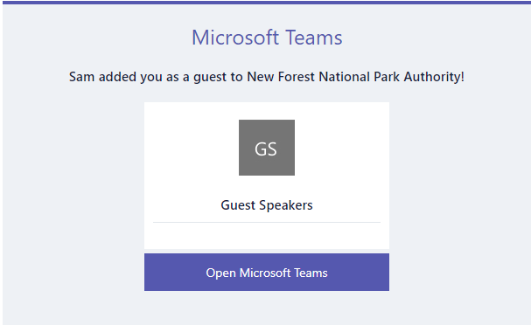
You will be asked to sign in. You will either be asked to enter your password or be required to send a verification code. Click the Send code button to have the code sent to your email address:
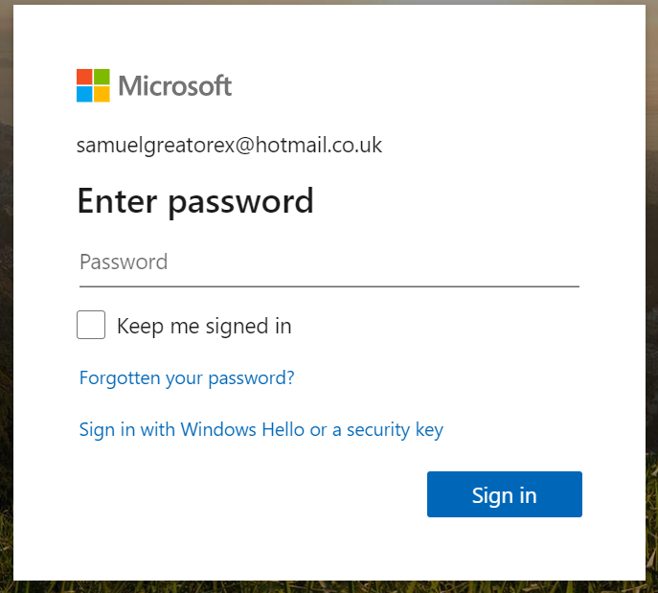
Enter your password/the code provided and then select Accept on the Review permissions page to finalise your guest account:
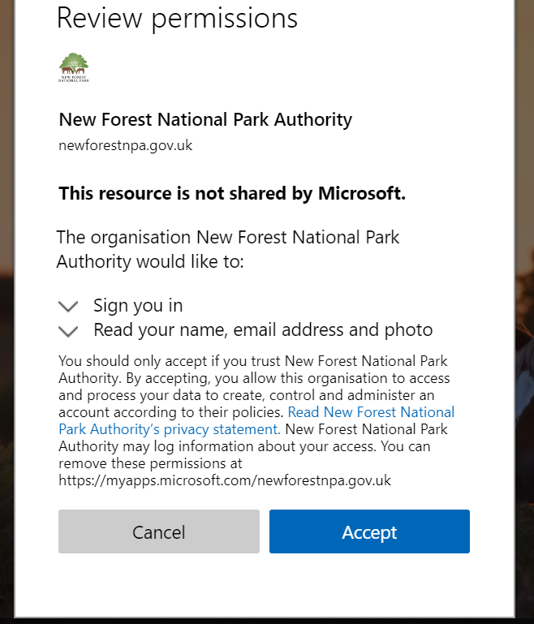
You will then be asked to download the Teams app. If you haven’t already got the app installed, click the Download the app button. If you have Teams installed, click the Launch it now link:
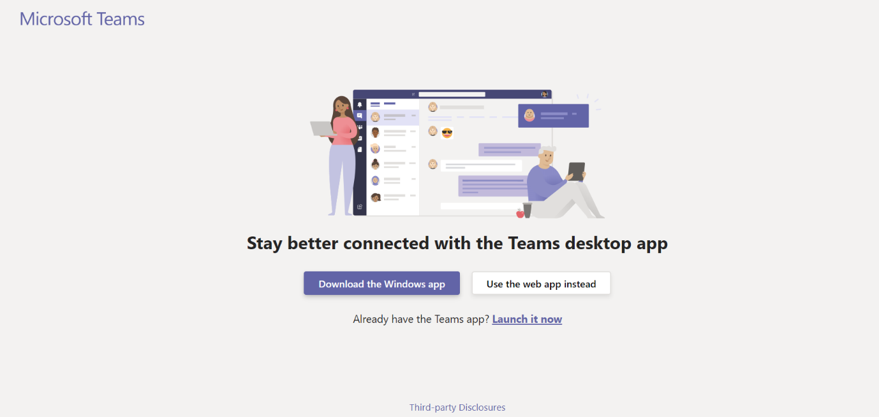
Once the app is installed, open it and sign in with the same email address. You will have to sign in with your password again/get a second code sent to complete the sign in process.
You will be sent an email invite before the meeting and this is how you will join the meeting. When it’s time if you open the invite, you will have a Join live event link:
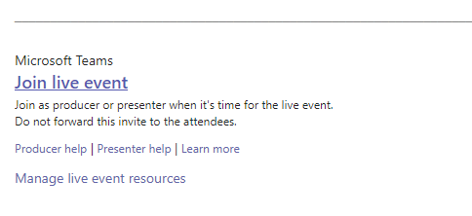
Click the link and make sure you open in the Teams application. If you try and join via the web app you will only be able to view the meeting – you will not be able to participate.
You will be taken to a screen where you can check that your mic and camera (if applicable) are working okay. It is recommended that you join with your microphone switched off. Once everything is set up and you are ready to join the meeting, click the Join now button:
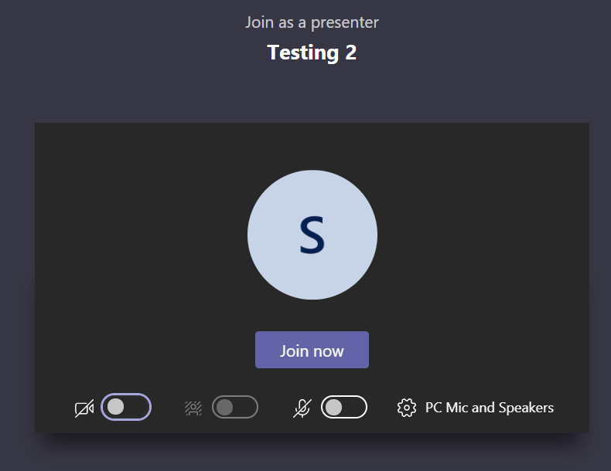

Guidance notes for Speaker

Preparation for the meeting
- As this is a virtual meeting of the Authority and will be live streamed to the public, the Chairman will start the meeting by giving a short overview as to how the meeting will progress.

- Natalie Walter (Principal Planning Officer) will present the applications; other officers present will be Steve Avery (Executive Director, Strategy and Planning), Rosalind Alderman (Solicitor and Monitoring Officer), David Stone (Corporate Services Manager), Simon Ludlow and Sam Greatorex from our ICT team and Vicki Gibbon (Member Services Administrator) who will minute the meeting.

Planning applications and public speaking
- Natalie will present each planning application using slides which will be viewable on the screen to all.

- The Chairman and members will have the speakers list. After Natalie has summarised the application, the Chairman will invite each speaker to address the Committee in the following order – applicant / person for the application, objector, parish representative for 3 mins (except the parish rep. who will not be time limited) – all will have a further one minute right of reply at the end of the debate and before a decision is taken by the Committee. We will advise speakers when their three minutes / one minute is up. Once you have made your presentation, members may wish to ask you questions on what you have said so please keep your microphone on until that is finished. Where a speaker is unable to attend the meeting directly, David Stone will read out their presentation on their behalf (in which case the speaker will not be able to make use of the one minute right of reply).

- Public speakers will be able to speak when invited to by the Chairman in the above sequence. In order to avoid background noise during the meeting, it is advisable to keep your microphone muted until it is your turn to speak. It is essential that public speaking is conducted in an orderly manner, please follow the directions of the Chairman carefully. If necessary, the Chairman is able to mute microphones if the need arises.

- Members will then debate the application and, when a recommendation is made, they will vote on the application. Rosalind Alderman will record the decision and the voting split.

- The meeting will be live streamed to the public who will be able to observe the meeting but not participate.

- If a technical fault occurs or the meeting does not have a quorum, the Chairman will suspend the meeting until the fault can be resolved or a quorum has been formed and the meeting will then resume.

