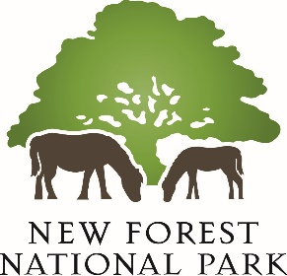

**Habitats Regulations Assessment / Appropriate Assessment**

**Project Brief and Invitation to Quote NFNPA – 0067**

**April 2025**

1. **Introduction** 
   1. The New Forest National Park Authority invites quotes from suitably experienced consultants to undertake a Habitats Regulations Assessment (HRA) and, where required, an Appropriate Assessment (AA), for the review of the New Forest National Park Local Plan. These assessments are required for local plans under the *Conservation of Habitats and Species Regulations 2017* (as amended), with further guidance provided in the National Planning Practice Guidance resource on [Appropriate assessment - GOV.UK](https://www.gov.uk/guidance/appropriate-assessment). The New Forest National Park Local Plan Review is a ‘plan or project’ that has the potential to impact the integrity of the range of internationally designated sites in and around the New Forest and therefore an assessment is required to ensure legal compliance. The project brief outlines what the Authority expects of its Habitats Regulations Assessment/appropriate assessment and the requirements for quote proposals.
2. **Background** 
   1. The New Forest National Park Authority adopted its current Local Plan in August 2019 and it forms the central element of the statutory ‘development plan’ for the National Park. The planning system plays a key role in the delivery of the two statutory National Park purposes (and related socio-economic duty) and the adopted Local Plan has provided a clear planning policy framework for the New Forest National Park over the last 5 and a half years.
   2. In 2024 the members of the New Foresty National Park Local Plan resolved that a focused update and review of the Local Plan was required to ensure it remained consistent with the latest national planning policies, guidance and legislation. For example, there have been several iterations of the National Planning Policy Framework (NPPF) since the Local Plan was adopted.
   3. As part of the current review of the New Forest National Park Local Plan a series of important evidence base studies have been commissioned, all of which are due to conclude by Spring/early Summer 2025. These include a Strategic Housing Market Area Assessment for the New Forest National Park (and surrounding areas within New Forest District Council’s planning remit); an Economic Needs Assessment covering the National Park; and a Gypsy & Traveller Accommodation Assessment.
   4. We undertook an initial Regulation 18 consultation on the ‘Direction of Travel’ for the Local Plan review in February – March 2025 with further details available at [New Forest National Park Local Plan Review 2025 - New Forest National Park Authority](https://www.newforestnpa.gov.uk/planning/local-plan/new-forest-national-park-local-plan-review-2025/). This initial Regulation 18 consultation invited feedback on the scope of the review of the local planning policies for the National Park area. We are in the process of considering the representations made during this consultation. Our Local Development Scheme (LDS, 2024 – see [Local Development Scheme - New Forest National Park Authority](https://www.newforestnpa.gov.uk/documents/planning/local-development-scheme/)) set out a timetable for further consultation at Regulation 18 on an initial draft Local Plan in late 2025, followed by Regulation 19 consultation on the Submission draft Local Plan in Summer 2026.

**3. The Study Area**

3.1 The study area for the Habitats Regulation Assessment/appropriate assessment is the whole of the New Forest National Park. The 220 square mile National Park was designated in 2005 and includes land within the counties of Hampshire and Wiltshire. As with all of the English and Welsh National Parks, the New Forest has two statutory purposes:

* To conserve and enhance the natural beauty, wildlife and cultural heritage of the Park; and
* To promote opportunities for the understanding and enjoyment of the special qualities of the Park by the public

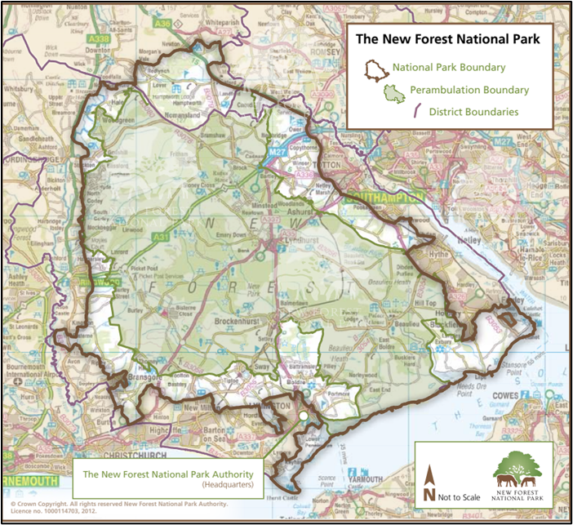

3.2 Working in partnership with other organisations, it is also the Authority's duty to seek to foster the economic and social well-being of the local communities within the New Forest. National Parks are recognised within the NPPF (December 2024) as having the highest level of protection in relation to landscape and scenic beauty (paragraph 189) and are identified as areas of restraint within paragraph 11 and footnote 7 of the NPPF (December 2024). National policy also recognises that National Parks are not appropriate locations for major development.

3.3 Importantly for the HRA/AA work the Authority is looking to commission, 56% of the New Forest National Park is designated as being of national or international importance for nature conservation (SPA, SAC, Ramsar) – the highest proportion of any local planning authority’s area in the country. These nature conservation designations cover the heathlands at the core of the National Park; the whole of the National Park’s 26 miles of coastline along the Solent coast and Southampton Water; and the Avon Valley in the west of the National Park. Established mitigation schemes are in place to address HRA impacts from new development on these internationally designated sites.

3.4 It is also a living-working landscape, with a population of circa 34,500 people which makes it one of the most densely populated National Parks in the country. The New Forest has a variety of settlements, with no villages larger than 3,500 people; and the National Park is home to around 2,500 local businesses. The National Park Authority deals with around 900 planning applications per annum.

3.5 With recent changes to national policy through the revised NPPF; and the revised Objectively Assessed Housing Need for the New Forest area established through the Government’s ‘standard method’, the review will consider continuing the approach of the current Local Plan (2019) of identifying a limited number of site allocations to meet identified needs. The National Park Authority has recently undertaken a ‘call for sites’ process and the results of this will feed into the review of the Local Plan.

**4. Project Description**

4.1 We are looking to engage consultants to undertake a full Habitats Regulations Assessment and, where required, appropriate assessment, of the New Forest National Park Local Plan Review. Given the range of international nature conservation designations in the New Forest, this assessment work will be a fundamental part of the evidence base for the Local Plan Review and a key input for the iterative process of preparing the revised Local Plan.

4.2 Under the Conservation of Habitats and Species Regulation 2017 (as amended) the New Forest National Park Authority is the ‘competent authority’ for the review of the New Forest National Park Local Plan. The National Park Authority must carry out an assessment to test if the plan could significantly harm the designated features of a European site. This process comprises the following steps, with further information available at [Habitats regulations assessments: protecting a European site - GOV.UK](https://www.gov.uk/guidance/habitats-regulations-assessments-protecting-a-european-site). The assessments should be undertaken in accordance with the relevant regulations and case law.

* **Habitats Regulations ‘Screening’ Assessment:** A precautionary assessment of whether the draft Local Plan policies are: (a) directly connected with, or necessary for, the conservation management of a European site; and (b) risk having a significant effect on a designated site either alone or in-combination with other proposals. At this stage mitigation measures should not be considered.
* **Appropriate Assessment:** Should the precautionary screening assessment be unable to rule out potential impacts on site integrity (either alone or in combination), an ‘appropriate assessment’ is required. This should assess the likely significant effects of the emerging local planning policies on the integrity of the site and its conservation objectives; as well as considering way to avoid of reduce (mitigate) any potential adverse impacts.

**5. Relevant Studies**

5.1 There are several published documents, evidence base studies and existing mitigation strategies which will be highly relevant to the preparation of the Habitats Regulations Assessment and appropriate assessment of the New Forest National Park Local Plan Review. We have undertaken HRA/AA work for many years and relevant existing assessments and reports include:

* New Forest National Park Local Plan Habitats Regulations Assessment (LUC, 2018) and Addenda (LUC, 2018, 2019) to consider the CJEU judgment in the ‘People Over Wind and Sweetman v. Coillte Teoranta’ – available on request.
* Habitats Regulation Assessment Screening Report for the New Forest National Park Partnership Plan 2022 – 2027 (NFNPA, [About the Partnership Plan - New Forest National Park Authority](https://www.newforestnpa.gov.uk/conservation/partnership-plan/about-the-partnership-plan/))
* Mitigating recreational impacts on New Forest designated sites SPD (NFNPA, 2020) - [Revised-Habitat-Mitigation-Scheme-SPD-.pdf](https://www.newforestnpa.gov.uk/app/uploads/2020/07/Revised-Habitat-Mitigation-Scheme-SPD-.pdf)
* Bird Aware Solent Recreation Mitigation Strategy - [Our strategy - Bird Aware Solent](https://birdaware.org/solent/about-us/our-strategy/)
* Footprint Ecology research reports into the recreational use of the New Forest’s designated sites, including the definition of the relevant ‘zone of influence’ and the recommended ‘Strategic Access Management & Monitoring’ (SAMM) package - [Research into recreational use of the New Forest’s protected habitats - New Forest National Park Authority](https://www.newforestnpa.gov.uk/conservation/managing-recreation/managing-recreation/research-into-recreational-use-of-the-new-forests-protected-habitats-footprint-ecology-2020/)
* Information on the approach to addressing water quality impacts (nutrients) on the protected sites of the Solent Coast and Avon Valley - [Mitigating recreational and nutrient impacts - New Forest National Park Authority](https://www.newforestnpa.gov.uk/planning/guidance-on-applying/supporting-documents/nutrient-mitigation/)
* Information on the air quality monitoring work undertaken within the New Forest Special Area of Conservation (being undertaken jointly with New Forest District Council) available on request.
* Conservation Objectives for the relevant designated sites – see [European Site Conservation Objectives for The New Forest SAC - UK0012557](https://publications.naturalengland.org.uk/publication/5727577884852224) for example.

**6. Notes on the format and status of the data**

6.1 The report should be provided in a format that can be uploaded onto the National Park Authority’s website, preferably in PDF.

6.2 The use of the Authority’s Ordnance Survey mapping, or data derived from it, will be subject to the signing of a Contractor’s Licence as provided under the Public Sector Mapping Agreement.

**7. Final Reports**

7.1 The HRA/AA work will require close liaison with National Park Authority officers and Natural England throughout the assessment process. At each stage of the process outlined in section 4 a draft version of the relevant report should be submitted in confidence to the Authority prior to completion of the final report. Once the final draft has been approved the Authority will require:

* 2 paper copies of each final report, including any Executive Summary or Non-Technical Summary; and
* Electronic copies, in Word and PDF format.

7.2 The appointed consultants may also be required to give evidence on behalf of the National Park Authority at the Local Plan Examination in Public which is due to take place in the first half of 2027. We would therefore ask you to provide an hourly/daily rate for this.

**8. Timescales**

8.1 The HRA/AA process is iterative and will be a key input into the drafting and refining of the revised New Forest National Park Local Plan. An indicative timetable for the main stages in project timetable is set out below.

|  |  |
| --- | --- |
| **Stage** | **Date** |
| Deadline for tenders to be submitted | 30 April 2025 |
| Consultants appointed and contract award | 2 May 2025 |
| Inception meeting | Within 2 weeks of the contract award |
| Habitats Regulations Screening Assessment | June – July 2025 |
| Appropriate Assessment of draft Regulation 18 (Part 2) Local Plan | August – September 2025 |
| Regulation 18 (Part 2) consultation on Local Plan | November – December 2025 |
| HRA/AA input into preparation of Regulation 19 Local Plan | January – June 2026 |
| Regulation 19 consultation on Submission draft Local Plan | July – September 2026 |
| Submission of Plan to Secretary of State | December 2026 |
| Independent Examination | January – June 2027 |
| Target date for Adoption of Local Plan | October 2027 |

8.2 It is expected that at least two update meetings will be held during the course of the initial Habitats Regulations Screening Assessment work, followed by further meetings at the appropriate assessment stage (which previous work in the New Forest indicates is likely to be required). It will also be necessary to provide regular updates on the Assessment’s progress by email. As outlined above, HRA/AA is an iterative process and will require on-going communication with the Authority throughout this process.

8.3 The final timetable for the project will be reviewed if necessary and agreed between the Authority and the successful consultant.

**9. The Tender Proposal**

9.1 Consultants tendering for this contract should include in their proposals:

* An outline of their approach to the work which should meet the requirements of the relevant legislation, case law and guidance, including the NPPG;
* A programme and timetable for the undertaking of the HRA and appropriate assessment reflecting the target dates listed above;
* Details of the consultancy’s experience in the area of Habitats Regulations Assessment/AA, together with two contacts for references relevant to the study;
* Details of the qualifications and experience of the team who would be undertaking the project;
* Confirmation that undertaking this project would not give rise to conflicts of interest;
* Full details of the pricing structure to be applied to the work. The pricing structure should show costs for each of the major elements in this study, including expected time spent on the work, personnel involved, rates charged and limits applied to expenses; and
* Particulars of public liability and professional indemnity insurances. Public Liability Insurance is required, with a limit of indemnity of not less than £1,000,000 (one million pounds) per claim or series of claims. In addition, the National Park Authority require the appointed consultants to have Professional Indemnity Insurance with a limit of indemnity of not less than £500,000 (five hundred thousand pounds) per claim or series of claims

9.2 Fixed price tenders should be all inclusive with VAT charges show separately. Please note that the anticipated budget from this work is in the region of £10,000 - £15,000.

9.3 All submissions must be made via our e-Procurement portal [In-tend](https://in-tendhost.co.uk/newforestnpa/aspx/Home) and must be submitted by **12 noon on Wednesday 30 April 2025.**

9.4 The contract will be awarded on the basis of the criteria including (i) price; (ii) relevant experience; (iii) understanding of the brief. While cost is obviously an important consideration for the Authority, the contract will not necessarily be awarded to the lowest price. The overall objective will be to appoint the consultant that offers the best overall value for money.

***In case of content query, please contact:***

David Illsley

Interim Head of Planning & Place

New Forest National Park Authority

[david.illsley@newforestnpa.gov.uk](mailto:david.illsley@newforestnpa.gov.uk)

Direct Line: 01590 646672

***For queries relating to the procurement process or any issues with our e-Procurement portal, In-tend, please contact:***

Tom Knott

Finance and Performance Officer

New Forest National Park Authority

[tender@newforestnpa.gov.uk](mailto:tender@newforestnpa.gov.uk)

Direct Line: 01590 646678

**10. Contract**

10.1 The contract will be let on a fixed price basis including all appropriate expenses and costs.

10.2 All submissions are required to comply with the New Forest National Park Authority ‘Standard Conditions of Contract for Services’ (attached) which will be used to draw up the contract with the winning contractor.



10.3 Payment will be made in three main stages: 10% at the inception meeting; 45% on the receipt of the final HRA Screening Report; and 45% on the receipt of the final appropriate assessment.

10.4 The copyright of the final reports and any appendices or other supporting information / outputs (including associated databases) will reside with the New Forest National Park Authority.

10.5 The Authority reserves the right to withdraw this contract opportunity without notice and will not be liable for any costs incurred by suppliers during any stage of the process

**11. Project Management**

11.1 Initial contact should be made with:

David Illsley

Interim Head of Planning & Place

New Forest NPA

Lymington Town Hall

Avenue Road

Lymington

SO41 9ZG

[david.illsley@newforestnpa.gov.uk](mailto:david.illsley@newforestnpa.gov.uk)

01590 646672

11.2 Please note that to ensure fair and open competition, all substantive responses to any questions raised by interested suppliers will be made available to all other suppliers where appropriate. Any such clarifications will be posted on our In-tend portal and you will receive email notification to make you aware of this (you must be registered on the site in order to receive these).