New Forest National Park Authority

Invitation to Quote: NFNPA – 0066

Whole Plan Viability Assessment

- Introduction

  - The New Forest National Park was designated in 2005 and covers 220 square miles in southern England within the counties of Hampshire and Wiltshire. The National Park is home to 34,500 people and has one of the highest population densities of any National Park in England. The largest villages in the National Park have around 3,000 residents. For planning purposes, the New Forest National Park has the highest status of protection in relation to landscape and scenic beauty and is recognised as an area where development is restricted. The Authority deals with around 900 planning applications per annum.

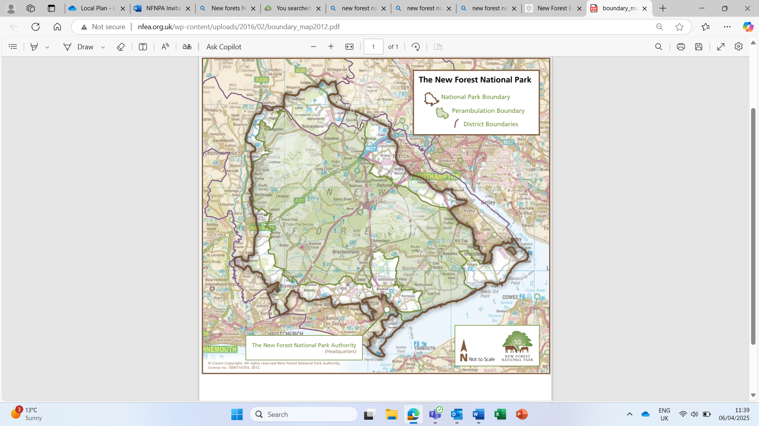

1.2 The National Park Authority is the sole statutory planning authority for the National Park, covering the development management, planning policy, enforcement and minerals & waste planning functions. These functions are not forecast to change following the process of local government reorganisation currently underway in Hampshire. As guardians of a national park, the New Forest National Park Authority has statutory purposes and socio-economic responsibilities as specified in the Environment Act of 1995:

- To conserve and enhance the natural beauty, wildlife and cultural heritage of the area; and
- To promote opportunities for the understanding and enjoyment of the special qualities of the Park by the public.

1.3 Working in partnership with other organisations it is also the Authority's duty to seek to foster the economic and social well-being of the local communities within the National Park. Please visit www.newforestnpa.gov.uk for more information on the New Forest National Park Authority.

- The Brief

New Forest National Park Local Plan Review – timetable

2.1 As part of its statutory planning role, the Authority is responsible for producing and updating the planning policy framework for the National Park. The Authority is in the process of reviewing its Local Plan for the National Park to cover the period to 2043 which will, once adopted, replace the adopted New Forest National Park Local Plan 2016 – 2036 (adopted August 2019 in full).

2.2 This process formally commenced in early 2025 and in February 2025 the Authority published an initial ‘Direction of Travel’ document for a 6-week period of public consultation to seek the views of the public and a range of consultees on the intended scope of the review. The Direction of Travel document outlines the range of national and international landscape and nature conservation designations that cover the National Park; and the likelihood that the future scale of development will be limited in accordance with the NPPF and the statutory Park purposes. The consultation summarises the current approach to housing in the adopted Local Plan, with a limited number of housing site allocations supplementing windfall development within the National Park to deliver circa 40 net new dwellings per annum. The local planning policy approach to housing mix, the proportion of affordable housing sought on windfall development sites, any future housing site allocations and rural exception sites are all ‘in scope’ for review. The recent consultation has also highlighted the opportunity to consider sustainable construction standards in the National Park and test options for the delivery of Biodiversity Net Gain at higher levels than the mandatory 10% target set out in national legislation. The Authority currently charges a BNG monitoring fee for £7,500 on developments where BNG is required.

2.3 The Authority is currently in the process of considering the responses received to the ‘Direction of Travel’ consultation held between February – March 2025, with the aim being to take a Regulation 18 (Part 2) draft Local Plan to the full Authority meeting in October 2025 prior to a further period of public consultation in November – December 2025. Full details of our Local Plan Review timetable can be found in the New Forest National Park Local Development Scheme (2024). Ultimately, we are aiming to submit our draft Local Plan and supporting evidence base by the Government’s deadline of December 2026.
2.4 As outlined above, a first full draft of our revised Local Plan is due to be considered by the full Authority meeting in mid-October 2025 prior to a further period of Regulation 18 public consultation. This draft Local Plan should be informed by high-level viability report findings, which will then go through further iterations as the National Park Authority prepares the Regulation 19 Submission draft Local Plan by June 2026. The viability work will need to be prepared in close consultation with Authority officers and is likely to be an iterative process.

2.5 In terms of wider background, the New Forest National Park Authority has not implemented the Community Infrastructure Levy and has no plans to do so. Developer contributions within the National Park are therefore typically secured through Section 106 legal agreements or Unilateral Undertakings. The range of infrastructure requirements vary between developments, with the most common developer contributions relating to addressing the impacts of new development (primarily housing) on the internationally designated nature conservation sites in and around the New Forest. This includes recreational pressures on the New Forest and Solent coast; and water quality (nutrients) on the Solent and River Avon designated sites. Mitigation schemes have been established for all these sites and the scale of developer contributions are summarised in Annex 1.

Project Brief

2.6 As part of the required evidence base for the review of the Local Plan, the Authority invites submissions and quotes from suitably qualified consultants with an established track record and relevant experience in the production of the following outputs:

A whole-Plan viability assessment of the emerging Local Plan (looking to 2043) | Required by the NPPG resource on ‘Viability’ - Viability - GOV.UK, which confirms that local planning policies should be, ‘…informed by a proportionate assessment of viability that takes into account all relevant policies, and local and national standards…’  The assessment should focus on the cumulative viability implications of the proposed planning policies on the cost of development. This is likely to involve a proportionate appraisal of the draft planning policies against a range of development typologies (e.g. greenfield and brownfield allocations, windfall development, conversions) and taking into account normal development costs in the National Park.
Advice on the viability of the various forms of affordable housing provision that can be supported within the National Park | This should be undertaken within the context of the Government’s clear emphasis on addressing local affordable housing needs through the development that does take place within National Parks and the significant local housing need.
2.7 The Authority expects the whole-Plan viability assessment to focus on the overall viability of the Local Plan and to ensure that it will not prevent the delivery of development within the National Park. In terms of affordable housing, the Authority is seeking advice through viability modelling on the overall percentage of affordable housing that is deliverable; the threshold at which on-site affordable housing is viable; and the appropriate level of financial contributions towards affordable housing where on-site provision cannot be sought. The whole Plan and affordable housing viability assessments must meet the requirements of the National Planning Policy Framework (20024) and National Planning Practice Guidance on ‘Viability’, which states:

“The role for viability assessment is primarily at the plan making stage. Viability assessment…should be used to ensure that policies are realistic, and that the total cumulative cost of all relevant policies will not undermine deliverability of the plan. It is the responsibility of plan makers in collaboration with the local community, developers and other stakeholders, to create realistic, deliverable policies. Drafting of plan policies should be iterative and informed by engagement with developers, landowners, and infrastructure and affordable housing providers. Policy requirements, particularly for affordable housing, should be set at a level that takes account of affordable housing and infrastructure needs and allows for the planned types of sites and development to be deliverable, without the need for further viability assessment at the decision making stage.’

2.8 As emphasised in the NPPG, the assessment should be proportionate and based on meeting the expectations of the Local Plan Examination. The successful consultant is also requested to state if they will be able to represent the Authority at the Local Plan Examinations on any matters relating to the viability assessment and provide an estimate of cost based on standard hourly rates.

Background information on viability

2.9 The most recent viability work undertaken at the Plan-making stage informed the adoption of the New Forest National Park Local Plan in August 2019. The report ‘Whole Plan, Affordable Housing and CIL Viability Assessment’ (Three Dragons with Rural Housing Solutions, November 2017) is available on request. The National Park Authority also holds information from more recent site-specific viability assessments undertaken for individual development sites within the National Park, which provide useful information on build costs and other factors.

2.10 By way of further context, Annex 1 sets out the background to development within the New Forest National Park. This highlights the particular planning framework for new development in the National Park, based around the high level of protection for the landscape and habitats; the strong emphasis in national policy on the delivery of affordable housing to meet local needs; and high house prices.

Methodology

2.11 The consultant should set out in their response to the invitation to quote their proposed methodology for the production of a viability assessment for the Local Plan (including the affordable housing policies). Assessment methodologies should follow established industry best practice and meet the requirements of the NPPF and the NPPG resource on ‘Viability’ to demonstrate the deliverability of sites to ensure the Local Plan is based on sound evidence.

2.12 Prospective suppliers should:
- Provide no more than 3 sides of A4 explaining their suitability, experience and approach to the brief.
- Include their proposed price for this work

- Evaluation

3.1 The evaluation will be undertaken on the basis of the most economically advantageous supplier to the Authority, taking into account both the indicative prices provided as well as the quality aspects of each respective bid. The Authority has not placed an indicative budget on this work, but would emphasise the need for a proportionate assessment that reflects the limited scale of future development planned within the New Forest National Park.

- Timeline

Stage | Date
Deadline for tenders to be submitted | 30 April 2025
Consultants appointed and contract award | 2 May 2025
Inception meeting | Within 2 weeks of the contract award
Engagement with development sector and review of evidence | June – July 2025
Assessment of draft Regulation 18 (Part 2) Local Plan | August – September 2025
Regulation 18 (Part 2) consultation on Local Plan | November – December 2025
Input into preparation of Regulation 19 Local Plan | January – June 2026
Regulation 19 consultation on Submission draft Local Plan | July – September 2026
Submission of Plan to Secretary of State | December 2026
Independent Examination | January – June 2027
Target date for Adoption of Local Plan | October 2027

4.1 The successful consultants will be expected to attend an initial inception meeting within 2 weeks on the contract being awarded with Authority officers to agree the main inputs into the assessments. Sample site typologies and case studies to be assessed will also be discussed and agreed. Further details of the work can be agreed in writing with the Authority during the course of the contract as required. There will need to be focused engagement with the development sector active within the New Forest National Park on matters such as build costs, materials and other factors that influence the viability of development. A copy of our Standard Conditions of Contract for Services can be found below:

4.2 All submissions can be made via our e-Procurement portal In-tend and must be submitted by 12 noon on Wednesday 30 April 2025.

4.3 Any queries must be made via the In-tend portal and any subsequent clarifications will be notified likewise (you will receive email notification from the In-tend system should this be the case).

4.4 The Authority reserves the right to withdraw this contract opportunity without notice and will not be liable for any costs incurred by suppliers during any stage of the process.

In case of content query, please contact:

David Illsley
Interim Head of Planning & Place
New Forest National Park Authority
david.illsley@newforestnpa.gov.uk
Direct Line: 01590 646672

For queries relating to the procurement process or any issues with our e-Procurement portal, In-tend, please contact:

Tom Knott
Finance and Performance Officer
New Forest National Park Authority
tender@newforestnpa.gov.uk
Direct Line: 01590 646678

Annex 1 – Background to development within the New Forest National Park

- Affordable Housing

  - The adopted New Forest National Park Local Plan (2019) contains several policies relevant to affordable housing delivery within the National Park.

- Policy SP27 (Affordable housing within the Defined Villages and on allocated sites) sets out the approach to affordable housing on developments of different sizes – set out below. The policy and supporting text confirm that a suitable mix will be determined through liaison with the local housing authority and the starting point is to seek 75% social/affordable rented tenure and 25% shared ownership/intermediate housing.

- Policy SP28 (Rural exception sites) supports small-scale rural exception site developments in the National Park. The policy states that 100% of the housing on rural exception sites will be affordable. The evidence base does highlight that a degree of flexibility may be required on the tenure of affordable housing on rural exception sites to ensure they are viable and the Local Plan therefore supports an element of shared ownership/intermediate affordable housing (25%) alongside affordable rented housing (25%).

1.2 National policy enables national park authorities to set lower site thresholds for affordable housing delivery than the national thresholds and this is reflected in policy SP27 of the adopted Local Plan, which has the current thresholds:

Development Size | Affordable Housing Requirements
Developments between 1 – 2 net new dwellings (inclusive) | No affordable requirement
Developments of between 3 – 10 net new dwellings (inclusive) | Target of 50% affordable housing. At the discretion of the Authority financial contributions is lieu of on-site provision will be accepted on smaller sites
Developments of 11 dwellings or more (net) | On-site affordable housing sought – target of 50% affordable housing.

1.3 The Authority’s adopted Local Plan (2019) also includes a policy limiting the size of net new dwellings to a maximum total inhabitable habitable floor area of 100 square metres (policy SP21). This applies to open market and affordable housing and equates to a typical three bed dwelling. The policy was put in place in response to the evidence of housing need in the National Park for smaller dwellings and the updated Housing Needs Assessment work for the Local Plan Review indicates the need for predominantly smaller dwellings remains.

- Habitat Mitigation measures

2.1 More than half of the New Forest National Park is designated as being of international importance for nature conservation. This includes the heathland habitats at the core of the Forest as well as significant parts of the National Park’s Southampton Water and Solent coastline.
4.2 In line with the relevant legal requirements, all development is required to ensure it will not affect the integrity of Natura 2000 sites. In terms of the scale of development that takes place within the National Park, this is typically achieved through financial contributions towards agreed recreational mitigation schemes for the New Forest and Solent habitats. Further details of these adopted mitigation schemes can be found at Development Impacts on Protected Areas - New Forest National Park Authority and Our strategy - Bird Aware Solent.

4.3 The level of financial contribution for addressing in-combination recreational impacts arising from new development within the National Park varies depending on the size of the dwellings and where it is located in relation to the respective ‘zones of influence’. For a typical new 3-bed dwelling located within the respective zones of influence, the contributions sought towards mitigating recreational impacts would be £4,374 for New Forest mitigation and £875 for the Bird Aware Solent mitigation scheme.

4.4 Development within the National Park is also required to address water quality impacts on the internationally designated sites of the Solent Coast (nitrates) or River Avon (phosphates), with further information available at Mitigating recreational and nutrient impacts - New Forest National Park Authority. There are a range of nutrient credit schemes available to development within the National Park, with Solent nutrient credits costing circa £3,500 per credit (with each net new dwelling in the National Park typically requiring circa 2 credits). The west of the National Park is located within the River Avon catchment, which is affected by phosphates. There are several phosphate credit schemes emerging and further information on the cost of credits will be available in due course.

Paragraphs 11, 189 and 190 of the National Planning Policy Framework, December 2024

