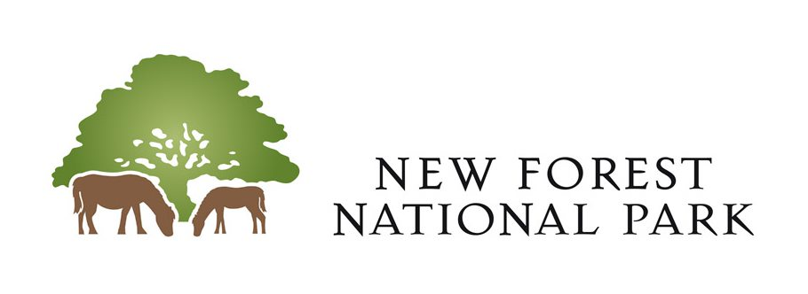

NEW FOREST NATIONAL PARK AUTHORITY

RECRUITMENT OF AN INDEPENDENT PERSON

INFORMATION FOR APPLICANTS
Background Information

New Forest National Park Authority

There are 15 National Parks in the UK. Known as Britain’s Breathing Spaces, National Parks are areas of spectacular landscape that include mountains, meadows, moorlands, woods, coasts and wetlands. Mostly farmed landscapes supporting living, working communities, National Parks are areas of protected countryside that everyone can visit and enjoy.

The New Forest was designated a national park in 2005 to give this outstanding landscape the highest level of protection and to preserve it for the nation to enjoy for generations to come.

The New Forest National Park Authority (the Authority) is the organisation responsible for promoting the purposes of the National Park and the interests of the people who live and work within it.
As a National Park, the Authority has statutory purposes and socio-economic responsibilities as specified in the Environment Act 1995.
- To conserve and enhance the natural beauty, wildlife and cultural heritage of the area.
- To promote opportunities for the understanding and enjoyment of the special qualities of the Park by the public.
Working in partnership with other local authorities and other organisations, it is also the duty of the Authority to seek to foster the economic and social well-being of the local communities within the National Park.
The Localism Act 2011

The Localism Act 2011 requires the Authority to adopt a code dealing with the conduct expected of Members of the Authority, to be consistent with the Seven Principles of Public life (the Nolan Principles) i.e. selflessness, integrity, objectivity, openness, accountability, honesty and leadership.

In addition, the Act requires the Authority to put in place a system to deal with any allegations regarding Members breaching the code including arrangements for investigating allegations and for making decisions regarding the allegations. The Authority must also appoint an ‘Independent Person’ whose view must be sought before the Authority can reach a decision on an allegation it is investigating.

Independent Person

Selection Criteria - Skills and Competencies

- The Independent Person will have:

  - a keen interest in standards in public life,
  - a wish to serve the National Parks communities and uphold local democracy,
  - high standards of personal integrity,
  - the ability to be objective, independent and impartial,
  - sound decision making skills,
  - questioning skills; and
  - leadership qualities, particularly in respect of exercising sound judgement.

The Independent Person will:

- be a person in whose impartiality and integrity the public can have confidence,
- understand and comply with confidentiality requirements,
- have a demonstrable interest in local issues,
- have an awareness of the importance of ethnical behaviours; and
- be a good communicator.

Desirable additional knowledge and experience:

- working knowledge/experience of local government or other public service and/or of large complex organisations and awareness of and sensitivity to the political process; and
- knowledge, experience and understanding of judicial/quasi judicial or complaints processes.

You should demonstrate in your application how you meet the above criteria as this will assist the short-listing process.

Eligibility for Appointment

2. A person cannot be appointed as an Independent Person if they are or, in respect of (a) below, if they were at any time during a period of 5 years prior to the appointment:

a. a Member, Co-opted Member or officer of the Authority; or
b. a relative or close friend of a person within category (a) above.

Term of Appointment

3. The appointment will be for a period of four years. The appointment may be terminated earlier where it is deemed, in the absolute discretion of the Authority, that the role holder has conducted himself/herself in a way which, if he/she was a Member/Co-opted Member of the Authority, would be a breach of the code of conduct.
4. The Independent Person will be eligible to be considered for reappointment via competitive recruitment process at the end of their term if they so wish.

Requirements of the Role

5. Requirements of the role include:

a. To assist the Authority in promoting high standards of conduct by Members of the Authority and in particular to uphold the Code of Conduct adopted by the Authority.

b. To be consulted by the Authority through the Monitoring Officer and the Standards Committee before it makes a decision on an allegation that it has decided to investigate, and to be available to attend meetings for this purpose.

c. To be consulted by the Authority in respect of a standards complaint at any other stage.

d. To be consulted by a Member of the Authority about whom a complaint has been made.

e. In any individual case where consulted, to advise the Authority of any pecuniary or non-pecuniary interest that the Independent Person has in the matter.

f. To act as advocate and ambassador for the Authority in promoting ethical behaviour.

g. To attend training events organised and promoted by the Authority.

5.1 The expected time commitment for this role is approx. 4 to 6 days per year, although this is dependent upon the number of complaints received. Meetings are generally held during normal office hours.

Expenses

6. The Independent Person is eligible to receive an annual allowance of £141.72 as well as travelling and subsistence expenses in respect of their duties.

Induction and Training
7. Induction and relevant training will be provided.

Recruitment Procedure

8. Applications shall be submitted in accordance with the instructions in the application form, to be received no later than noon on 23 August 2024. Please note that, in completing the application form, candidates should give evidence of the experience they have of applying the skills and competencies set out in section 1 above.
9. A short-listing process will be undertaken, and applicants invited for interview will be notified in writing.
10. All candidates interviewed will be notified as soon as possible after interview as to whether or not they are being recommended for appointment.

Further information
11. It is hoped that the information set out in this note answers most of the questions that potential applicants may have about the role. For further information, you may find the following website of interest:
New Forest National Park Authority – www.newforestnpa.gov.uk
12. Potential applicants may also contact David Stone Corporate services Manager (David.stone@newforestnpa.gov.uk) or Vicki Gibbon (vicki.gibbon@newforestnpa.gov.uk) Member Services Administrator for an informal discussion about the role.
Dated: 2 August 2024

a person (“R”) is a relative of another person if R is: (a) the other person’s spouse or civil partner, (b) living with the other person as husband and wife or as if they were civil partners, (c) a grandparent of the other person, (d) a lineal descendant of a grandparent of the other person, (e) a parent, sibling or child of a person within paragraph (a) or (b), (f) the spouse or civil partner of a person within paragraph (c), (d) or (e), or (g) living with a person within paragraph (c), (d) or (e) as husband and wife or as if they were civil partners.

