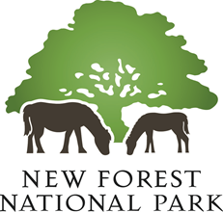

The New Forest National Park
Revised Habitat Mitigation Scheme

Developer Contribution levels

To enable an applicant to secure mitigation for the recreational impacts of a new development to satisfy the requirements of the Habitats Regulations through a contribution to the NPA’s Revised Habitat Mitigation Scheme the following financial amounts apply:

 | From  1 Jan 2023  to 31Dec 2023 | From  1 Jan 2024  to 31Dec 2024
Per each net new dwelling | £4,031 | £4,301
Per new additional bedroom of serviced  visitor accommodation | £3,144 | £3,355
For all other forms of development | Please refer to Revised Habitat Mitigation Scheme SPD

Please read these contribution levels in conjunction with the Revised Habitat Mitigation Scheme SPD, which can be found on:
https://www.newforestnpa.gov.uk/planning/development-impacts-on-protected-areas/

The level of contribution has risen from the previous year in line with inflation, as described in Paragraph 14.3 of the Revised Habitat Mitigation Scheme SPD.
All other types of visitor accommodation, including self-catering, will be determined on a case by case basis and regard will be given to the occupancy of the accommodation provided. Please contact the Authority to discuss.

