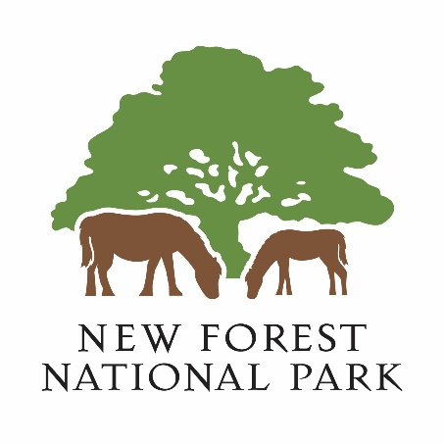

New Forest Oral History Group

Oral history is the recording of an interview between a narrator with personal experience of past events and an interviewer, with the goal of adding to the historical record. Oral histories give the listener a unique experience of history as told by a person that lived through that history.
Following our very successful New Forest Remembers WWII project, during which our volunteers recorded over 150 interviews, the New Forest National Park Authority is looking to re-establish the New Forest Oral History Group.

Group Aims
- To record memories of (past and present) life and events in the New Forest area
- To work with existing oral history archives relating to the New Forest area
- To make these memories publicly accessible

What does the group do?
- Records audio (Oral History) interviews with people
- Records other audio content in relation to oral history interviews
- Transcribes oral history interviews
- Edits audio recordings to help improve accessibility
- Publishes audio recordings* and transcripts
- Produce other public access content derived from the oral history archives
- Work with other groups and archives to make oral histories more accessible

Where?
- Most interviews are conducted at the interviewees home but can be conducted in other locations, such as out in the New Forest
- Transcription and editing can be done at home or in our office
- Publishing can be done at home or in our office

Group roles
Interviewer:
Conducts the interview, recorded via a digital audio recorder. Following the interview, the Interviewer transcribes audio recording into a written word-for-word document. With the addition of some form filling this is the main task.
Transcriber:
We often need help transcribing interview recordings. This is the production of a written word-for-word transcript of the audio recording. The final document is very much like a script for a play, capturing the spoken word in written form.
Presenter:
This role is about working with the content from our and/or other oral history archives to produce (with the help of an Editor, if needed) standalone audio programs like podcast or radio programs.
Editor:
The role of an editor is to extract sections from the full interview recording to produce standalone audio clips. These clips can be published and/or use in other audio programs. The editor can also produce (with the help of a Presenter, if needed) audio programs like podcasts or radio programs.
Publisher:
This role is about working with the content of our and/or other oral history archives to publish the material online. This involves working with all the material in the archive to make it publicly accessible.

Training and experience:
No previous experience is needed, all training will be provided. However, if you do have knowledge and experience of oral history interviewing, dictation/touch typing, audio editing, audio recording, presenting and/or online publishing we would love to have you join the group.

Equipment:
All recording equipment is provided. If you wish to volunteer from home, you will need a PC (Mac or Windows), be able to create and edit MS Word documents, be able to listen to MP3 audio files and have internet access. To work with and edit audio files, you will also need to install some free open-source software called Audacity www.audacityteam.org.

Want to know a bit more?
Contact: Gareth Owen
Direct Line: 01590 646652
Mobile: 07880 383988
Email: archaeology@newforestnpa.gov.uk

Want to join the Group:
Please sign up by registering as a “Archaeology and heritage” volunteer via: www.newforestnpa.gov.uk/communities/volunteer/volunteer-with-us/volunteer-registration
Please send Gareth an email, to let him know you’ve signed up.

* It is not always possible to publish the entire interview recording. In most cases we only publish clips taken from the full interview.

