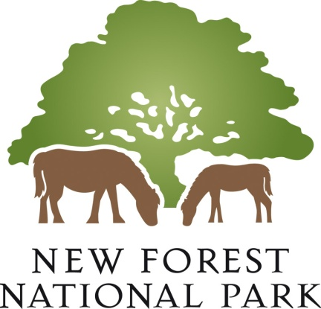
Volunteer Fair 2023 Programme of talks
All talks are in the exhibition room (first floor); talks are a maximum of 10 minutes with 5 minutes for questions afterwards
10.40am Volunteering with Freshwater Habitats Trust
Thea Margetts, Freshwater Habitats Trust
11.00am Volunteering with Guide Dogs for the Blind Association
Lee Thresher, Guide Dogs for the Blind Association

11.20am Fire Safety in the Home
Hampshire Fire and Rescue, Lee Joss
11.40am Volunteering at the Heritage Centre and New Forest Airfields Memorial
Dr Henry Goodall, Friends of New Forest Airfields

12.00am Volunteering with Tools for Self Reliance
Lauren Smits, Tools for Self Reliance
12.20pm Volunteering with CPRE Hampshire
Amanda Roberts, CPRE
12.40pm Finding solutions together: helping New Forest residents through their difficult times
Citizens Advice New Forest, Sallie Southam
1.00pm Volunteers and the Countryside Education Trust
Chris Chappell, Countryside Education Trust
1.20pm Volunteering with Step up safe space
Suzanne Moore, Step up safe space

1.40pm Hampshire Search and Rescue - A different type of volunteering
Trevor Vidler, Hampshire Search and Rescue
2.00pm Volunteering with the RSPB in the New Forest
Saul Alonso Aradas, Anneka Schofield, RSPB
2.20pm Volunteering with Woodlander Coppice
Paul Brockman, Woodlander Coppice

2.40pm Conservation, Coppicing & Charcoal - making volunteering fun & informative
Derek Tippets, Pondhead Conservation Trust

3.00pm The role of ‘Ward Friend’ supporting patients and staff at our local hospital
Arthur England, Lymington Hospital Friends
3.20pm Foxlease volunteering – not just for Girl guides!
Bryan Davies, Foxlease Girlguiding Activity Centre, Bryan Davies
3.40pm Volunteering with New Forest Agricultural Show Society,
Sarah Cooper, New Forest Agricultural Show Society

