Invitation to Quote

Evaluating Green and Blue Horizons from City to Forest

Introduction

The New Forest National Park Authority is seeking a consultant to assess the impact of ‘Green and Blue Horizons from City to Forest’ project. The project is funded by a £539,200 grant from the Government's Green Recovery Challenge Fund which aims to kickstart environmental renewal and create and retain a range of jobs. With match funding, it represents a £800,000 investment in the New Forest.

Background
Green and Blue Horizons from City to Forest is a partnership project led by the New Forest National Park Authority (NPA) and delivered by the NPA and four of its partner organisations based in the New Forest: Countryside Education Trust, Freshwater Habitats Trust, Hampshire & Isle of Wight Wildlife Trust, and the New Forest Commoners Defence Association. Green and Blue Horizons began in September 2021 and is due to complete in March 2023.
Green and Blue Horizons is funded by a £539,200 grant from the Government's Green Recovery Challenge Fund. The fund was developed by Defra and its Arm's-Length Bodies to help charities and environmental organisations start work on projects across England that restore nature and tackle climate change. The fund is being delivered by The National Lottery Heritage Fund in partnership with Natural England, the Environment Agency, and Forestry Commission. Green and Blue Horizons partners are collectively bringing another £255,000 in match funds from a range of sources.
Green and Blue Horizons contributes to the fund’s three themes:
- Nature conservation and restoration – improvements to the physical state of the natural environment, including making it richer in plants and wildlife.
- Nature based solutions – improvements to the physical state of the natural environment that help people and nature adapt to the effects of climate change and natural disasters.
- Connecting people with nature – a wider range of people benefit from the natural environment, including feeling more connected to the place where they live.
Green and Blue Horizons also contributes to the fund’s two economic benefits:
- Job creation and retention – direct employment created or sustained to deliver the project and jobs created indirectly through the supply chain.
- eNGO capacity and resilience – financial resilience of organisations as well as changes in assets, skills and capabilities, strategies, and plans.
Aims and objectives

Green and Blue Horizons is aimed at kickstarting action to confront the twin climate and nature emergencies with programmes to restore habitats, begin our path towards net zero with nature, and help new and diverse audiences connect with the New Forest. Our focus is on the areas around the edge of the National Park boundary. Most of these are farmed landscapes and smallholdings that sit in between the highly protected core Open Forest landscape and the towns, cities, and coastline surrounding the National Park.

Green and Blue Horizons will:

- Create wildlife-rich corridors, thriving wetlands, to buffer and extend SSSI network, link habitats to Bournemouth and Southampton (nature restoration).
- Reduce land-based emissions by restoring habitats, working with farmers, landowners, land managers to develop climate resilience (nature-based solutions).
- Develop volunteering and outreach focussing on those with most to gain, who will become more connected with nature and gain new pathways to employment (connecting with nature).
- Create or retain 17 jobs and involve around 50 local contractors (jobs and skills).

About the NPA

We are responsible for conserving and enhancing the New Forest National Park and promoting understanding and enjoyment of the things that make it special. As well as our planning, nature conservation and public engagement responsibilities, our services include education, recreation, and archaeology.

https://www.newforestnpa.gov.uk/conservation/green-and-blue-horizons-from-city-to-forest-scheme/green-and-blue-horizons-from-city-to-forest-scheme/

The brief

We are seeking a consultant who can help us to evaluate Green and Blue Horizons and understand its impact against the Green Recovery Challenge Fund’s three themes and two economic benefits. This will involve data collection and analysis and the development of a final written report for the NPA and partner organisations. The report will also be shared with the National Lottery Heritage Fund as part of the terms and conditions of funding.

A framework has been developed to act as a guide for prospective evaluators (annex 2) and indicative research questions are:

- To what extent did the project achieve its aims?
- How effective is the project at achieving outcomes for nature, climate, and people? Were there any unexpected outcomes?
- What impact has the programme had on partner organisations?
- What changes could be made to achieve the best outcomes for beneficiaries and partner organisations?
Providers are invited to design alternative or additional research questions and methods if they add value to or deepen our understanding of what works and why.

A range of quantitative data will be collated by the NPA and partner organisations and made available to the successful evaluators. A summary is provided in Annex 3. Providers should review the summary and suggest additional quantitative data that could be collected by partner organisations to assist with analysis.

Whilst we will be collecting quantitative data associated with nature conservation and nature-based solutions, we recognise that it will be difficult to demonstrate the project’s impact on nature and climate by March 2023 (when the project is due to end) as it is unlikely that any results will be identifiable by then. Instead, our focus will be on outlining the changes that we would expect to see and how this will be monitored beyond the life of the project.

We anticipate that most of the data collected by evaluators will be qualitative using a range of methods focused on beneficiary and partner engagement, for example:

- Surveys to determine people’s attitudes, awareness, engagement, behaviours, wellbeing, and skills.
- Surveys of volunteers’ confidence and skills during the project.
- Qualitative interviews with a representative sample of participants and partners to provide more in-depth understanding of the project’s impact and future potential.
- Individual stories of change and case studies to illustrate impact.
- Website and social media data to monitor engagement with online presence.
- Comparison data from project partners where possible and particularly relevant to determine the effect of participating in the project versus not participating.

You are encouraged to state which methods and approach will be most effective to achieve the research questions. Providers are invited to design alternative or additional research questions and methods if they add value to or deepen our understanding of what works and why.

Some qualitative data will be collected by the NPA and partner organisations as part of the development of a film about the work that has been undertaken in Green and Blue Horizons. This will focus on the themes of nature, climate, connection to nature, and the jobs that it has supported. This will help draw out some of the individual stories from those taking part and be used as part of the project’s legacy to help build further links into neighbouring communities and develop the ‘city to forest’ theme further.

In summary, your proposal should include your method and approach to:

- Reviewing the research questions and suggesting any additional or alternative research questions or approaches you feel appropriate.
- Reviewing the data summary given in Annex 3 and suggesting additional quantitative data that could be collected by partner organisations to assist with your analysis.
- Collecting qualitative data that will be most effective to achieving the research questions.
- Assessing and analysing the data.
Within your proposal, please give a detailed breakdown of how you intend to allocate the budget across these areas.

Outputs/deliverables
The following outputs will be required:
- Presenting an initial summary of findings to the NPA and partner organisations.
- A final written report in word presented to the NPA and partner organisations.
- A set of research data, to be stored in a readily accessible electronic format such as Excel.
The contract
We are seeking a supplier:

- With experience of a wide range of local and national knowledge in evaluating externally funded projects
- With an understanding of the New Forest National Park or similar protected landscape
- With an understanding of the key issues in the New Forest and surrounding urban and rural areas.
Bids will be assessed using a price (30%), quality (70%) matrix.

Budget – up to £10,000

Prospective suppliers should:

- Provide no more than four sides of A4 explaining their suitability, experience, and approach to the brief.
- Provide CVs for relevant staff.
- Include their proposed number of hours/days to achieve this work and the hourly/daily rate applicable.
- Be prepared, if successful, to evidence Professional Indemnity Insurance of at least £50,000.

Timeline

Stage | Date
Proposal deadline | August 17th - noon
Contract award | August 22nd
Inception meeting with key NPA and partner representatives | Aug/Sept – exact date TBC
Initial summary of findings | December 2022
First draft report | Early February 2023
Final report | March 2023

All submissions must be emailed to tender@newforestnpa.gov.uk and must be submitted by 12noon on 17th August 2022.

Any queries must be made via the same email address.

For queries relating to the procurement process (only), please contact:
Nigel Stone
nigel.stone@newforestnpa.gov.uk
01590 646655 / 07775 847473

Annex 1 project framework

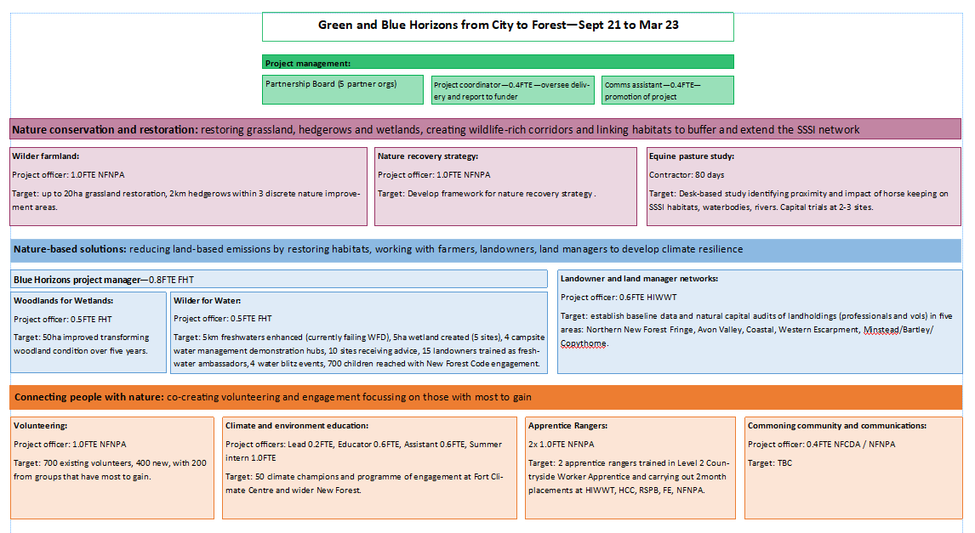

Annex 2 – Project Plan

Annex 3 – summary of quantitative data collected by NPA and partners (GRCF data log)

 | Activity and output reporting |  | What we will provide
Location data  Project activities |  | GIS data is preferred if available for large sites –a shape file showing the extent and boundary of large sites.  Otherwise, OS grid reference, Lat/Long or post code, including for locations of engagement activity.
1. Area of land benefitting  from GRCF activity |  | Hectares of land / habitat that has benefitted, including:  Direct benefit – area of land where project activity is taking place  Area of wider benefit (for example habitat connectivity or catchment-wide benefits)  For habitats or features not measurable in hectares, use km (e.g., rivers or hedgerows)
 | 2. Type of land benefitting  from GRCF activity |  | For the area of land that has benefitted:  Whether the land / habitat is protected or designated (e.g., SSSI).  Type of habitat at each site. [Note – we plan to use the UK BAP Priority Habitats list but will accept other responses for different types of sites]  Condition of land / habitat –  Baseline condition  Condition at project completion (where possible)  [Note –where possible, such as for SSSIs, this will be the common standards here: Natural England Standard: SSSI Monitoring and Reporting -NESTND035]
 | 3. Type and condition of  species targeted |  | What species the project will target  Baseline information on species at site  Observed improvements at site at project completion (where possible)
 | 4. Tree planting (excluding  replacement or replanting) |  | Number of trees planted at each site in the reporting period (e.g., the last quarter)  Species of trees planted  [Note – we will ask for numbers of trees in addition to hectares of tree planting as in point 1.]
 | 1. Visitor infrastructure improved or installed |  | Kilometres of footpath installed / improved in the reporting period (e.g., last quarter)  New signage  Other infrastructure improved/installed
 | 2. People engaging with  project activities |  | Number of people attending events or taking part in activities.  Types of activity (e.g., citizen science, workshop, guided walk)  Whether you are targeting specific underrepresented audiences (e.g., yes / no + tell us more)  We do not need to collect demographic data about all visitors / participants. We would like to know about activities where you are engaging specific groups/communities based on their protected characteristics (including, for example, age, ethnicity, or disability) or social and economic background.
 | 3. Volunteering |  | Number of new volunteers recruited  Number of volunteer days / hours  Whether you are recruiting from underrepresented groups (e.g., yes / no + tell us more)
 | 1. Employment  This will include:  Direct jobs – people employed by the grantee / a partner organisation.  Indirect jobs – for example someone employed by a contractor. |  | Jobs created by GRCF (number, full time equivalent (FTE), contract length and role titles)  Jobs retained for GRCF (number, FTE, contract length and role titles)  Number of jobs supported through Full Cost Recovery (number and FTE)  Number of Kickstart placements/ jobs  Equalities data on new roles recruited (where collected)  Estimate of jobs/apprenticeships created or retained by contractors
 | 2. Skills |  | Number of paid apprentices / trainees for: lead applicant, partners and contractors Project over £250,00  Age of apprentices / trainees  Title and level of apprenticeship, and/or titles of any certified course completed  Equalities data on trainees (where collected)  Number of other employees who have been trained through the project  Number of volunteers who have been trained through the project

