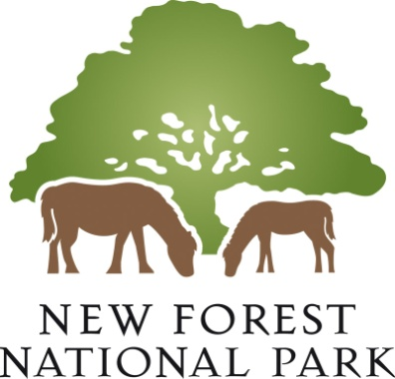

TOWN AND COUNTRY PLANNING (GENERAL PERMITTED DEVELOPMENT) (ENGLAND) ORDER 2015 (as amended)

NOTICE OF MAKING OF A DIRECTION PURSUANT TO ARTICLE 4(1) IN RESPECT OF LAND AT LOT 2, PETLAKE FARM, RINGWOOD ROAD, BARTLEY, SOUTHAMPTON (SO40 7LA), KNOWN AS ‘TERRY’S PATCH’

TAKE NOTICE that the above mentioned Direction was made pursuant to article 4(1) of the Town and Country Planning (General Permitted Development) (England) Order 2015 (as amended) by the New Forest National Park Authority, being the appropriate local planning authority on 3 November 2020. The Direction will come into force on 9 November 2020.

The effect of the Direction will be to withdraw permitted development rights pursuant to Class A of Part 2 of Schedule 2 of the aforementioned Order (the erection, construction, maintenance, improvement or alteration of a gate, fence, wall or other means of enclosure) unless express planning permission is subsequently granted by the appropriate local planning authority to permit development of that Class.

The Direction and accompanying Plan have been placed and may be seen free of charge at the offices of the New Forest National Park Authority, Town Hall, Avenue Road, Lymington, Hampshire, SO41 9ZG, between the hours of 10.00 am and 2.00 pm Monday to Friday. In view of the current coronavirus pandemic, it is requested that an email is sent at least 24 hours prior to visiting to dev.control@newforestnpa.gov.uk. Copies of the Direction and Plan are also available to view on the Authority’s website at https://www.newforestnpa.gov.uk.

Any representations about the Direction should be made at any time from 9 November 2020 but no later than 14 December 2020 addressed to the Enforcement Manager, New Forest National Park Authority, Town Hall, Avenue Road, Lymington, Hampshire, SO41 9ZG or by email to dev.control@newforestnpa.gov.uk, quoting “Article 4 Direction – Cadnam – Class A Part 2 of Schedule 2 GPDO”.

In deciding whether to confirm the Direction, the New Forest National Park Authority shall take into account any representations that are received no later than 14 December 2020.

Dated 3 November 2020
Alison Barnes
Chief Executive
New Forest National Park Authority

