CLA and New Forest National Park Awards 2020 – criteria

You do not need to match all criteria to enter, but please provide evidence of meeting as many of these criteria points as possible.

To qualify, nominees must live, work or practise within the awards boundary on the last page.

Young Farmer / Commoner (40 years and below)

Engages in and represents Forest life
Demonstrates commitment to wildlife/environment
Evidence of a forward-thinking approach to farming/commoning
Encourages and supports other young farmers/commoners
Active member of a young farmer/commoner organisation
Evidence of a sustained commitment to farming/commoning

Best Supporter of Local Produce

Produces and/or sells/uses local produce
Prioritises quality of product
Promotes/champions local produce
A member of the New Forest Marque
Evidence of support for local produce over a sustained period of time
Offers advice and support to other local producers
Takes an innovative approach to producing their product or selling products
Makes use of new technology to promote local produce

Sustainability Champion

Promotes/utilises renewable/sustainable energy
Responsible for initiating or driving involvement in a sustainability project
Has made sustained efforts to reduce their consumption of utility services
Evidence of measures taken to reduce the impact of transportation
Evidence of measurable, sustainable change as a result of work undertaken
The project/individual goes above and beyond standard sustainability practice
Project is likely to continue to operate for the foreseeable future

Rural Diversification

Any rural diversification in Hampshire
An innovative project which benefits the wider business it sits within
Brings jobs and growth to the rural economy
Sustainability at the heart of the scheme
Project considers and enhances its local environment

Land Management

Encourages engagement with the natural environment e.g. Open Farm Sunday/
school and educational visits
Uses resources from the natural environment in a more sustainable and efficient way
e.g. water, renewable energy, public benefits
Resource protection – e.g. infield buffer strips, protecting water courses and tree planting
Engages in voluntary initiatives – CFE, Cluster Farming, Big Farmland Bird Count
Delivers habitat restoration and connectivity, including enhancing existing features for
farmland wildlife e.g. beetle banks, conservation grazing
Engages with existing Agri-Environment/Countryside Stewardship Schemes delivering environmental, heritage and ecological benefits
Enhances biosecurity
Improves soil health

The Land Management award reflects the contribution made by landowners, land managers and farmers to maintaining and enhancing the countryside and natural environment.

Young Environmental Champion (25 years and below)

Aged 25 or younger, living or working within the awards boundary (see map)
Leads or engages in projects to improve the natural world
Improves people’s understanding of the state of the environment, the benefits a healthy
environment can bring, and the effect of their actions on the natural world
Helps communities and business to reduce their impact on the environment through
greener decision-making
Inspires people to enrich the environment, encouraging individuals and organisations
to actively improve their local environment.

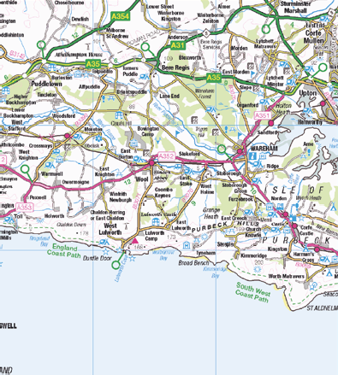
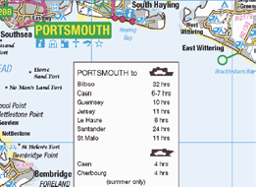
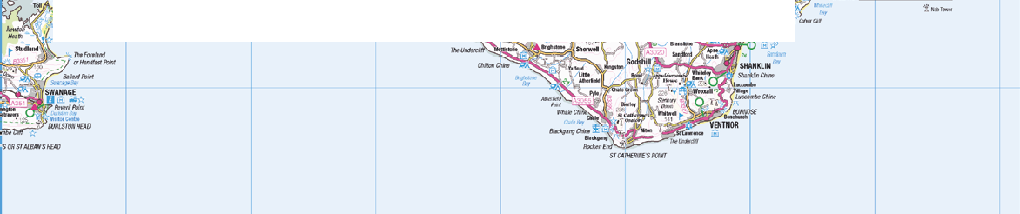
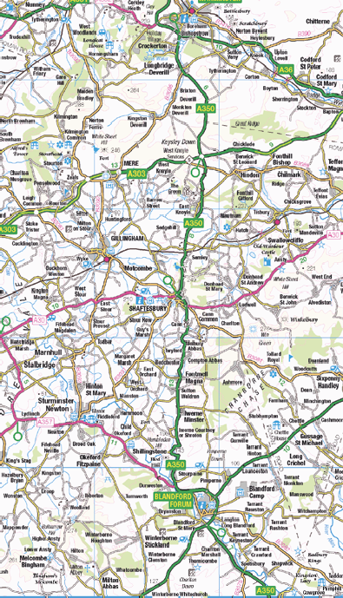
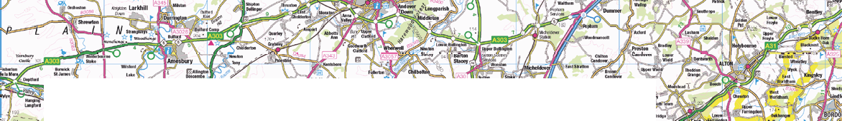
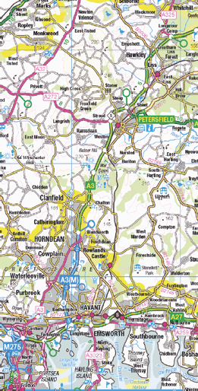
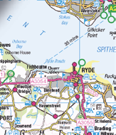
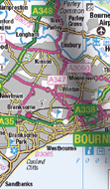
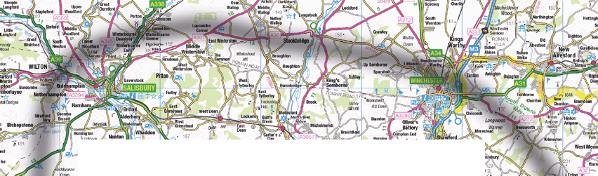
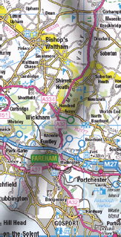
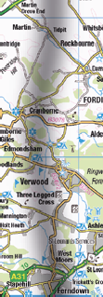
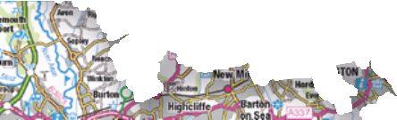
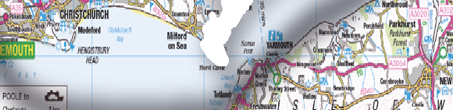
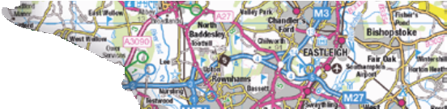
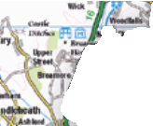
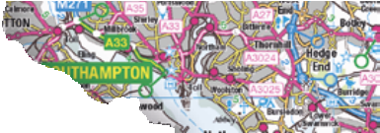
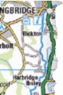
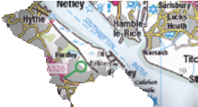
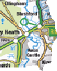
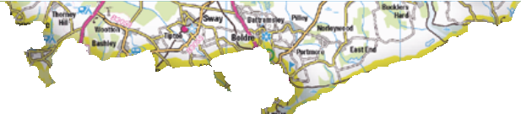
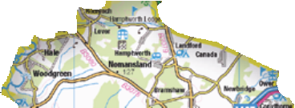
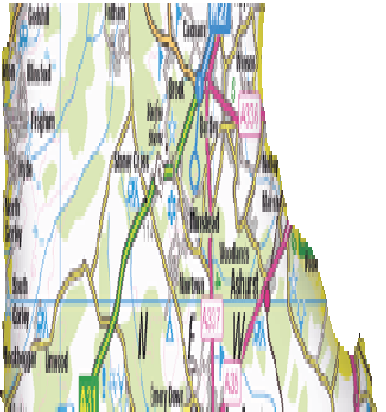
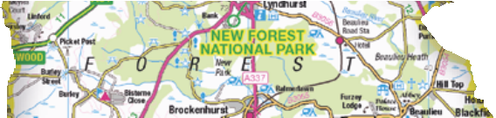
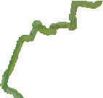
NPA 00945

Awards boundary

Awards
New Forest National Park

Not to scale.
© Crown copyright and database rights 2019 Ordnance Survey 100014703.

