Guide to using the online interactive planning Policies Map

Menu
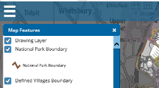

The menu on the top left-hand side of the screen allows several options:
- Map features – the various designations shown on the map are included as separate ‘layers’ which can be turned on or off.

- Measure – distances between any points on the map can be measured

- Zoom to coordinates – allows users to input easting and northing coordinates to find a specific location

Map features:
The map shows several different designations that are referred to in the policies of the New Forest National Park Local Plan. These are set out as separate ‘layers’, and the tick boxes on the key indicate which designations are currently showing on the map (as highlighted below).
These boxes can be unticked to remove those designations from the map, which can be useful as the designations on the map overlay each other.

Clicking on any part of the map will bring up some information about the layers in that area, for instance the name of a nature conservation designation, or a conservation area. Clicking on the cross in the top right of the information box, or on ‘close all’ will close the information box.
Measure:
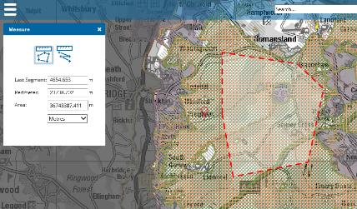
The symbol on the left (circled above) can be used to measure the perimeter and area of a shape, by clicking on the map to drag a shape around the area you’re interested in, and finish by double clicking.

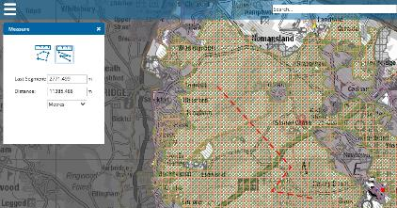
The symbol on the right (circled above) can be used to measure a line (straight or zig zag) by clicking on the map, and double clicking to finish.

Search:
It is possible to search for a specific location or address using the search box (as circled in the image below). One can search by the house / property name, street name, or postcode, and then clicking on the correct address in the resulting list will take you straight to that point on the map.

Capture:
On the top right hand side of the screen is a feature called ‘Capture’ which enables a screenshot of the map. Zoom to the particular area you are interested in and click ‘Capture’. Follow the instructions on screen to download or save an image of the map. Clicking on the back button of your web browser will take you back to the original map.

