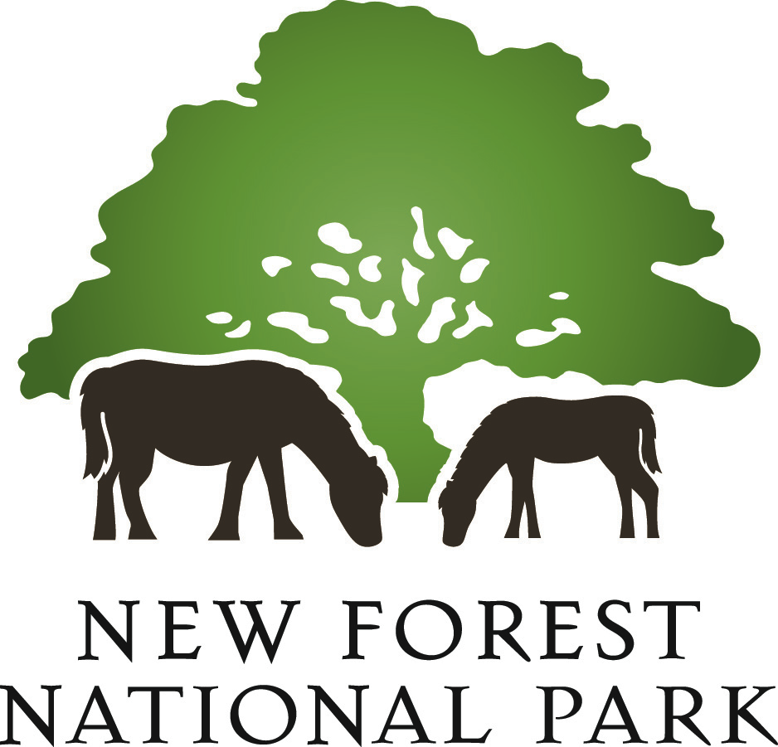
Forest South
Ashurst
Lyndhurst Road
Lyndhurst Road is a detached 4 bed house built circa 1910 in the Arts & Crafts style with solar PV and rainwater harvesting system.  Richard drives a Nissan Leaf 2.0 which is mainly charged from the solar PV system, supplemented by a 100% renewable (and vegan!) electricity supply. | Richard Barnett  112 Lyndhurst Road, Ashurst, SO40 7AU  023 8029 2531  07791990351  rbarnett@phonecoop.coop | - Electric car  - Insulation (roof/walls)  - Rainwater harvesting  - Solar PV  - Wildlife friendly garden
 | Sat: 10-12 | Sun: 1-4

Beaulieu

Patricks Patch
Patricks Patch was developed from a paddock into a community space and learning garden.  Growing fruit, veg, herbs and flowers the produce is used nearby in Steff’s Kitchen.  Head Gardener Rachel will give talks about composting on Sunday 30th at 10.30am and 2.30pm. | Rachel Foster  Fairweather’s Garden Centre, High Street, Beaulieu, Hampshire, SO42 7YB  01590 612 307  info@fairweathers.co.uk | - Composting talk  - Fruit, veg, herb and flower growing
 | Sun: Compost talk at 10.30 & 2.30

Beaulieu (cont).

Sustainability Workshop - some simple steps to reduce your carbon footprint!
This will be a fun, challenging, informative and very active day.  Through a series of demonstrations, hands on activities, puzzles and videos we will asking and answering questions like what is climate change? What is a carbon footprint? How is climate change affecting the New Forest? Is there anything I can do? Can saving the earth also save me money?  You will need to arrive ready for indoor and outdoor activities regardless of weather.  Tea and coffee will be provided but please bring a packed lunch. | Barry Cullimore  Fort Climate Centre Countryside Education Trust  Home Farm  Palace Lane  Beaulieu  SO42 8AH  01590 612401  mail@cet.org.uk | Saturday 29 June 2019  10:00am - 3:00pm  Suitable for adults and children aged 10 and over.  Tickets – booking required  Per person: £20.00  Parent & child (2 people): £35.00  Additional person: £17.50  Book online: https://www.cet.org.uk/event/78926-Sustainability-Workshop  Or by phone: 01590 612 401
 | Sat: 10-3

Brockenhurst
Boost Bike Hub
E-bikes offer unique solutions to the challenges of any ride whether it is for fun, fitness or getting around.  On or off road, they’re perfect for those who want to explore more or just get there a bit faster. Even if your ride varies from day to day, an electric bicycle always gives you the option to do and experience more.  Boost Bike Hub is offering demonstration rides on selected E-bikes. This is a great opportunity to try before you buy and find out more. | Boost Bike Hub  2-4 Brookley Road, Brockenhurst SO42 7RR  01590 624204  hello@boostbikehub.co.uk | - E-bike demos
 | Sat: 9–5 | Sun: 10-4

East Boldre

New Forest Estates
Based near Beaulieu in The New Forest since 2005, we have become a leading supplier of estate cars and more recently electric and hybrid vehicles.  We have a Nissan Leaf available to test drive and will be happy to answer any questions. | Brain Reeves  Main Road  East Boldre  SO42 7WL  01590 671 338  07968 488810  brian@newforestestates.co.uk | - Electric vehicle test drive
 | Sat: 8.30-3pm

Lymington
Brackenhurst
Brackenhurst is a 4 bedroom detached timber frame contemporary house completed in 2013 to PassivHaus standards.  The building is highly thermally efficient with walls, floors and roof insulated and triple glazing installed. A 4400L rainwater harvesting tank provides water for toilets and washing machine.  A range of technologies provide heat, hot water and electricity resulting in the property being almost self-sufficient. | Bill Peach  Brackenhurst  Broadmead, off Silver Street,  Nr Lymington  SO41 6DH  01590 681376  07802 739961  bill@billpeach.com  Directions: bridleway off Silver Street nr. The Mill  Please note that entering postcode into SatNav might not take you to the right location. Stay on the tarmac part of bridleway and do not turn right up the unmade lane. | - Biomass  - Energy efficient lighting  - Insulation (roof, walls, floors)  - Rainwater harvesting  - Reed bed effluent treatment  - Sedum roof  - Solar PV  - Solar Thermal  - Triple glazing  - Ventilation system  - Woodburning stove
 | Sun: 11-4

Cowley Road
Paul Frampton is a local solar and renewables installer and has used his knowledge to improve the sustainability of his home.  Cowley road is a five bedroom detached chalet bungalow clad in cedar with three solar PV systems, solar thermal panels and battery storage, high levels of insulation, woodburning stove and a heat recovery system.  Paul also has knowledge of heat pumps, biomass, WIFI and weather compensating heating controls and how renewables should nit together to create the most efficient solution. | Paul Frampton  22 Cowley Rd  Lymington  SO41 9JQ  07802 661147  paul@barryframpton.co.uk | - Double glazing (non upvc)  - Electric car  - Energy efficient lighting  - Heat recovery system  - Insulation (roof/floor/walls)  - Led lighting  - PV Hot water emersion controller  - Solar PV  - 9.6kW battery storage system  - Solar thermal  - WIFI PV monitoring and heating controls  - Woodburning stove
 | Sat: 10-12.30  NB note amended time | Sun: 10-3

Efford Mill
Efford Mill dates back to the Domesday Book. Most of the building is Georgian/Victorian solid brick with tile/slate roofing. It is a large, rambling property and difficult to insulate effectively. Hot water and heating is supplied to the original radiators and newer under floor heating by a ground sourced heat pump located in the river bed. Three wood-fired stoves supplement the heating and a 4 kW solar photovoltaic system mounted in the garden provides electricity. The old mill waterwheel is undergoing restoration with a view to setting up a micro-hydro power installation, which will generate energy to power the heat pump | Fiona & Jeremy Rogers  Efford Mill  Milford Road  Lymington  SO41 0JD  01590 672 576  07484 291 950  rogersfmo@btinterenet.com | - Ground source heat pump  - Insulation (roof/part floors)  - Solar PV  - Water butts  - Wildlife friendly garden  - Woodburners
 | Sun 2-5

Lymington (cont.)
Pennington Solar Farm
West Solent Solar Cooperative is the only community owned solar farm in the New Forest.  A former landfill site the 2 megawatt solar farm  produces enough energy to power 650 homes. The site has been planted with wildflowers to provide maximum benefits for wildlife.  No booking is required. For groups of ten or more people and those with additional needs, please get in touch so we can make sure your needs are met. | Cathy Cook  02380 283491  cathyc@westsolentsolar.coop  Access is ONLY possible via Lower Pennington Lane, Lymington (SO41 8AL), where direction signs into iley Lane will be displayed.  A weblink showing the solar farm location is here. | - Solar PV farm  - Wildflowers  - Hedgerows
 | Sat: 10-2

St Thomas Churchyard
St Thomas’s churchyard dates back to around 1250, and as a green oasis in the town of Lymington we started to manage it for wildlife in 2017. Our efforts have been recognised with first Bronze and now Silver Eco-Church Awards. Come and find out what we’ve done and how you can improve your garden for wildlife.  Guided tours of the churchyard will take place every half an hour from 9am to 12.30pm on Saturday 29th June. | St Thomas Churchyard  01590 676194  office@lymingtonchurch.org  St Thomas Churchyard, St Thomas Street, Lymington SO41 9ND | - Wildflowers  - Wildlife improvements
 | Sat: tours 9-12.30

Green Hub
The green hub will have a lots of bits and pieces to help you save water, reduce food waste and save money.  Discount vouchers for compost bins are available as well as free rice scoops and no junk mail stickers.  They’ll be an opportunity to switch energy supplier and join Citizen Energy, Southampton City Councils own energy provider, supplying 100% renewable energy.  Information on recycling will be available and a Nissan Leaf electric car to view. Andy Brennan the National Parks Sustainability Officer will be on hand to answer any questions. | Andy Brennan  Lymington Town Hall  Avenue Road  Lymington  SO41 9ZG  01590 646 676  andy.brennan@newforestnpa.gov.uk | - Discount vouchers for compost bins  - Electric car  - Free water efficiency devices  - Recycling information – what can you recycle and where?  - Reduce food waste  - Renewable energy supplier  - Renewable energy systems information – how they work
 | Sat: 11-4 | Sun: 11-4

Marchwood

Ipley Manor
Ipley Manor is a 200 acre farm with an 18th century brick-built manor house and four detached cottages, three Victorian and one later 20th century timber frame. A biomass district heating system was installed in 2007 providing all the heating and hot water demands of the manor house and four cottages. A biomass boiler burns woodchip harvested on site from 80 acres of woodland, the logs are dried for over a year before being chipped. | John Pemberton  Manor House  Ipley Manor  Marchwood  Hampshire  SO40 4UR  02380 842379  johnlpemberton@compuserve.com | - Biomass district heating system
 | Sun: 1-4 (NB opening time has changed)

Milford on Sea
Wynford
Wynford is a four bedroom, three storey detached house built in 2011, constructed of ICF (insulating concrete formwork), with further insulation that makes this property very thermally efficient. EPC rating is A 93. A 4000L tank captures rainwater which is used to flush toilets and supply the washing machine.  Solar photovoltaics, solar thermal, a woodburning stove and air source heat pump provide space heating, hot water and electricity. To maintain the high thermal efficiency and air tightness of the building a whole house ventilation system is used to provide fresh air. | Chris Sanders & Sue Towndrow  Wynford  Barnes Lane  Milford on sea  SO41 0RL  01590 645 442  chris@wynford.org.uk | - Air Source Heat Pump  - Energy efficient lighting  - Heat recovery & ventilation system  - Insulation (roof, floors, walls)  - High thermal mass and low thermal bridging  - Rainwater harvesting  - Solar PV  - Solar thermal  - Woodburning stove
 | Sat: 9-1 | Sun: 9-1

Minstead
Minstead Study Centre
Minstead Study Centre is a residential centre in the heart of the Forest, with sustainable living at the core of its ethos.  The site is 7 acres with woodlands, meadows, ponds, sheep and chickens. There is also a large ½ acre vegetable plot, which is farmed as sustainably as possible and used by children as part of their learning experiences.  The beautiful and award-winning accommodation block was built on sustainable building principles, using solar thermal heating, rainwater harvesting and an array of other technologies. It provides a wonderful environment for a residential visit. | James Dawkins  (centre manager)  Minstead Study Centre  School Lane  Minstead  Lyndhurst  SO437GJ  02380 813437  Minstead.sc@hants.gov.uk  The whole site will be available to stroll round (no booking required), with a number of our staff team on hand to answer questions | - Eco-friendly insulation  - Energy monitoring  - Rainwater harvesting  - Solar thermal  - Timber building  - Vegetable garden (1/2 acre)  - Wildlife friendly  - Wood burners
 | Sat: 10-3

New Milton
Woodcutters
Dan and Jane manage to live almost carbon neutral in their fifty year old bungalow by combining a 6.4 kW photovoltaic system with solar thermal flat plate collectors, woodburning stoves and other low-tech solutions. Dan has super insulated a single room which is heated by an air to air heat pump and drives an electric car.  They also grow their own veg which is kept watered through rainwater collection and have experimented with bio-char. | Dan and Jane Fish  Woodcutters  St Johns Road  Bashley  New Milton  BH25 5SD  01425 610 332  danfish.surface@btinternet.com | - Air to air heat pump  - Electric car  - Heat recovery/ventilation system  - High insulation levels  - Super insulated room  - Rain water collection  - Solar PV  - Solar thermal  - Woodburner with back boiler  - Veg garden
 | Sat: 11-4 | Sun: 11-4

Norleywood
Frogmore Cottage
Frogmore Cottage was built in 1967, the detached 4 bedroom property is set in 3 acres. Much has changed / been added to over the years. With no central heating system, woodburners heat the whole property and electricity is provided by Solar PV.  The garden has a large veg patch and fruit trees | Ben Williams  1 Frogmore Cottages, Norleywood, Lymington, SO415RX  01590 626356  07891 167971  (use WhatsApp as poor mobile signal at property)  bencharleswilliams@gmail.com | - Heat recovery/ventilation system  - Insulation (roof, floor)  - LED lighting  - Solar PV  - Triple glazing (in parts)  - Veg garden  - Wildlife friendly garden  - Woodburners
 | Sat: 10-5

Totton
Testwood Lakes Nature reserve
Four areas are open to visit including a wildlife garden designed for use with children to allow them to get closer to nature.  A dry garden built by Southern Water (owners of the site) and planted with drought tolerant species and two ponds created to attract wildlife.  Volunteer will be on hand to answer any questions. | Sam Dawson  Brunel Road  Calmore  Totton  Hampshire  SO40 3YD  02380 667929  Testwoodlakes@hiwwt.org.uk | - Dry garden  - Wildlife garden  - Wildlife ponds
 | Sun: 1-4

Sway

Widden Close
South facing 2 bedroom 1960’s brick detached bungalow with timber frame extension. The house has no gas connection and is heated with a wood stove and electric heating.  A large solar installation provides power and rainwater harvesting and a composting loo help reduce water usage. The a triple glazed extension is non-toxic with wood and hemp fibre insulation. | Tom Greenwood  7 Widden Close  Sway  Lymington  SO41 6AX  01590 683 057  07786 325 586  tomogreenwood@gmail.com | - Compact fruit trees  - Insulation (Roof, walls, extension floor)  - Lazy veg growing  - Led lighting  - Rainwater harvesting  - Solar PV  - Triple glazing (extension)  - Wood burning stove  - Heat recovery ventilation (bathroom)
 | Sun: 10-12.30

Forest North

Fordingbridge
Willow Avenue
18 Willow Avenue is a bungalow built some 30 plus years ago. Ten years ago an air-source heat pump was installed and solar panels were subsequently added. Edgars ambition is to produce enough power to be self-sufficient using the National Grid only as a buffer, the gas supply has been completely cut off. | Edgar Moss  18 Willow Avenue.  Fordingbridge,  SP6 1LH  01425 653970  edgar.moss@gmail.com | - Air-source heat pump  - Energy efficient lighting  - Insulation (roof//walls)  - Solar PV  - Solar thermal  NB Sunday opening time has changed
 | Sat: 2.30-5.30 | Sun: 3.00-5.30

Hale
Woodruff Cottage
Woodruff cottage was built in 1956 as a 3 bedroom detached bungalow and extended in 1995 by the current owners with 2 rooms in the loft space and a kitchen extension with cellar. A solar thermal system provides the majority of hot water during the summer months and a woodburning stove supplements the heating system in the winter. A 3.7kW solar PV system was installed in 2011. Richard and Paula also have a large vegetable garden using the no-dig approach, greenhouse and chickens providing lots of sustainable food! | Richard and Paula Downard  Hale  Open Sunday by appointment only contact owners to book and for address  01725 510 577  07725 441239  richard.downard@gmail.com | - Energy efficient lighting  - Insulation (roof, floor, wall)  - Solar PV  - Solar thermal  - Woodburner  - Veg garden
 | Sunday from 12.00 (appointment only)

