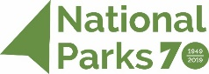
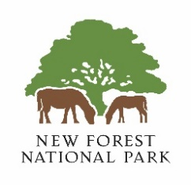
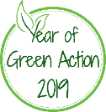

Our Green Action micro-grants - application form

In 2019 we’re celebrating the 70th anniversary of National Parks with a year-long drive to get more people from all backgrounds involved in projects to improve the natural world. Lots of small actions really do make a difference so we have grants of up to £150 available to schools and youth groups for green actions that benefit young people.

Please complete the information below and send your completed form to ourgreenaction@newforestnpa.gov.uk

Applications must be received by 31 March 2019. These will be reviewed by a grants panel at the New Forest National Park Authority during April and you will be informed of their decision no later than Tuesday 23 April.

Please tell us – who are you?

Name of your school or organised group:

Your name:

Your role:

Contact email address (this must be a named adult with an organisation email address)

What do you want to do? (please include scale and amounts where possible, for example – X packets of wildflower seed to cover X area)

What do you need to do this and how much it will cost? (please show your workings)

Why do you want to do this? Convince us! We are particularly keen that children and young people have the chance to develop green actions so let us know who has been involved in developing the idea.

This action will help towards (please tick the relevant boxes):

☐ Connect – Improving people’s understanding of the state of the environment, the benefits a healthy environment can bring, and the effect of their actions on the natural world.

☐ Protect – Helping communities and business to reduce their impact on the environment through greener decision-making.

☐ Enhance – Inspiring people to enrich the environment, encouraging individuals and organisations to actively improve their local environment.

Please check with your school finance team or club treasurer:

- In submitting this application form, please confirm that you are not aware of any potential breach in EU State Aid rules as a result of receiving this grant ☐

- Please confirm that only irrecoverable VAT is included in your costs ☐

Privacy Statement

The New Forest National Park Authority (NPA) needs to hold your personal data and contact information in order to administer the ‘Our Green Action’ grant process. Your information will be held securely and is accessible to New Forest National Park Authority staff and shared with the Chair of the grants panel.

We will not use your information for any purposes other than those described above, nor will it be supplied to anyone outside the NPA without your consent, unless we are obliged by law to disclose it, or it would otherwise be lawful and fair for us to do so. If your application contains personal data of people other than yourself, for example those who support your project or benefit from your project’s work, we will treat this in the same way. You must tell the individuals and if they have any questions about this, you must refer them to this notice.

Once this round of grant funding has been determined we will delete your details from the database within two months (unless your project application has been successful, in which case we will retain your information for up to six years after the end of the project).

Our privacy notice can be viewed at: https://www.newforestnpa.gov.uk/privacy-cookies/. You can request more information about how we hold your data by contacting the NPA’s Information and Data Protection Officer, Mrs Jo Murphy, by email (dpo@newforestnpa.gov.uk) or phone (01590 646653) or by post care of the NPA (Lymington Town Hall, Avenue Road, Lymington, Hampshire, SO41 9ZG).

